Steel Guitars Of Canada

CARTER-STARTER /

MAGNUM / CARTER PRO

PARTS CATALOG

Nov. 2022

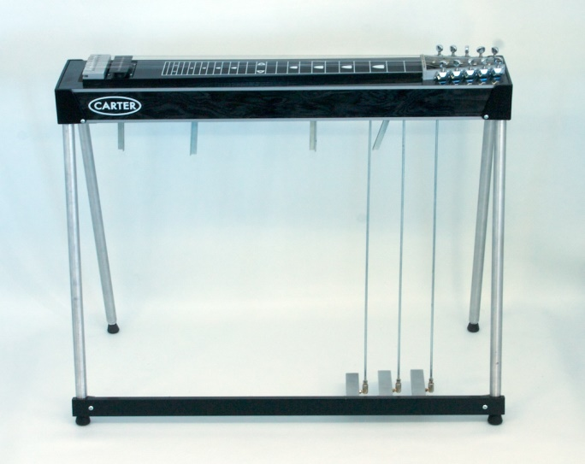

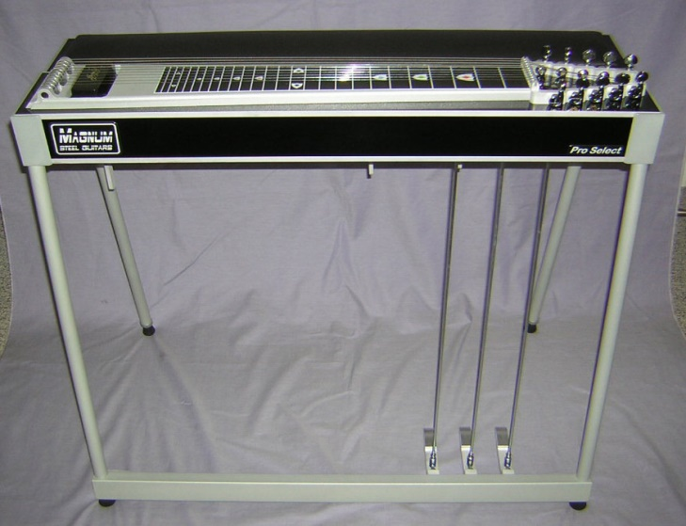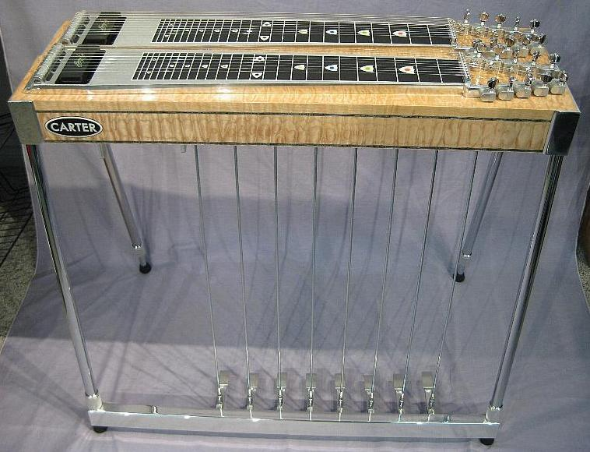

566 Dudley Rd., Colborne, ON K0K 1S0 Canada ~ Phone: 905-355-3056
E-Mail: steelcan@steelguitarcanada.com ~ Web Site: http://www.steelguitarcanada.com

Contact: Al Brisco

To Order

Order online at www.steelguitarcanada.com
Send an e-mail c/o steelcan@steelguitarcanada.com

-(or phone) with your requested items;
(Toll Free Order Line, 1-877-673-6394 Canada & USA)

-(or Mail using the Order Form on the last page;

(Remember…there is a $40.00 product minimum on mail orders)

We need your address & phone # to obtain a shipping quote, then we can get back to you with the postal shipping options & any applicable taxes.

We will then need to determine method of payment…Visa, MasterCard, Money Order, Interac e-transfer Bank Transfer (Canada Only), etc.

Thanks, Al Brisco

CARTER-STARTER PARTS

#C-S 040 – CARTER-STARTER DECAL - $10.00 

#C-S 021 – C-S KEYHEAD W/TUNING KEYS 5T/5B - $100.00 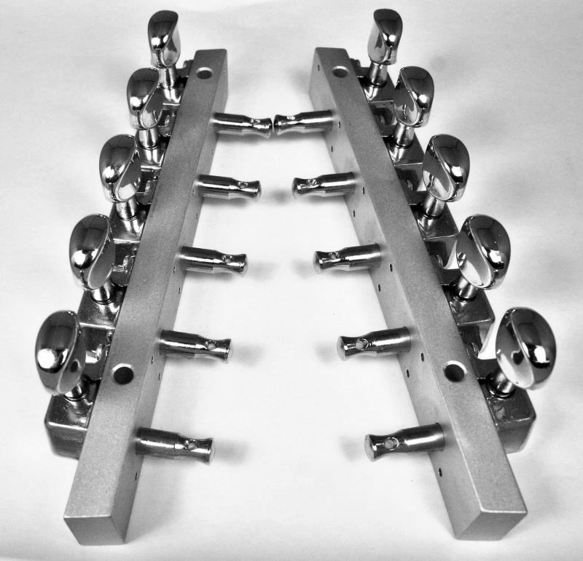

#C-S 022 – C-S PULL ROD (Specify Length) - $15.00 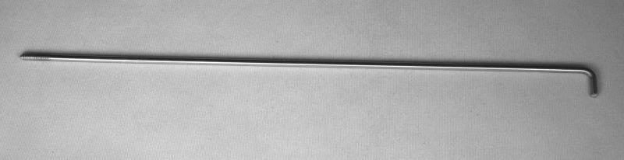

#C-S 020 – C-S NYLON TUNER (1½” for 3/32 Rod w/4-40 Thread) - $1.00 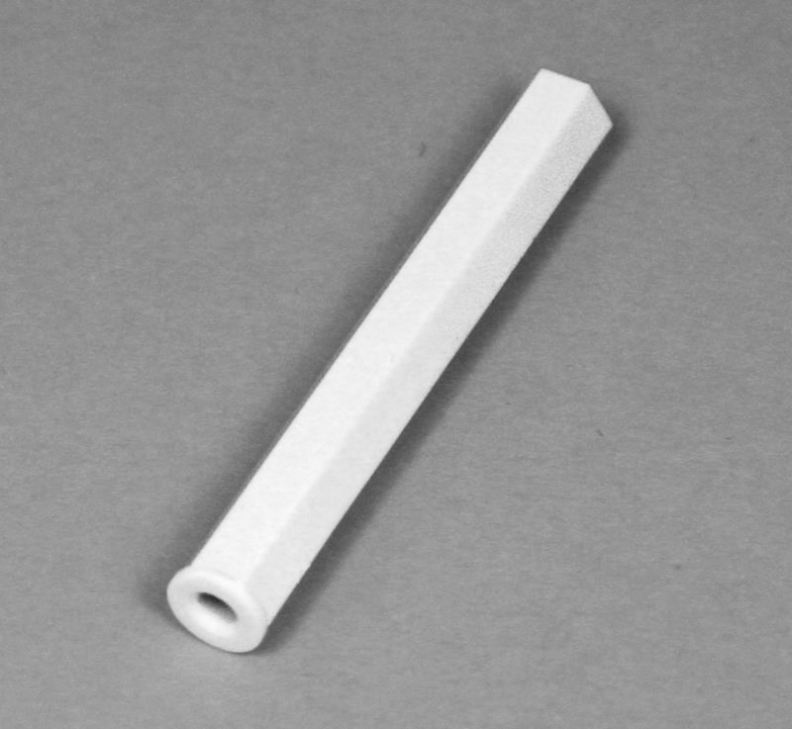

#C-S 039 – CARTER-STARTER FRETBOARD - $35.00
(18 11/16” x 2 11/16” Narrow End + 3¼” Wide End)
(474 mm x 69 Narrow End + 77 mm Wide End)
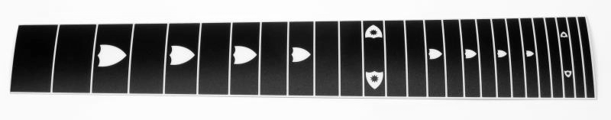

#C-S 017K +1 – C-S 1 INCH OVER-HEIGHT KIT - $80.00 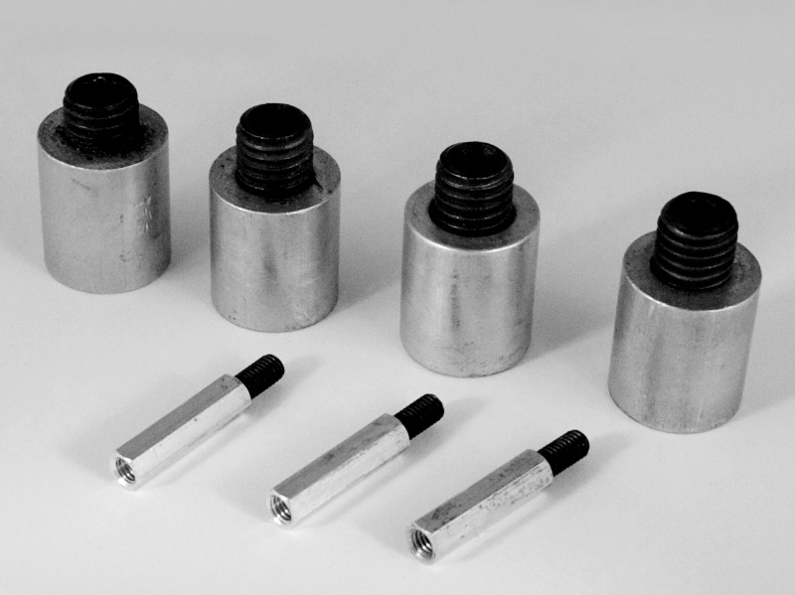

#C-S 017K +2 – C-S 2 INCH OVER-HEIGHT KIT - $80.00 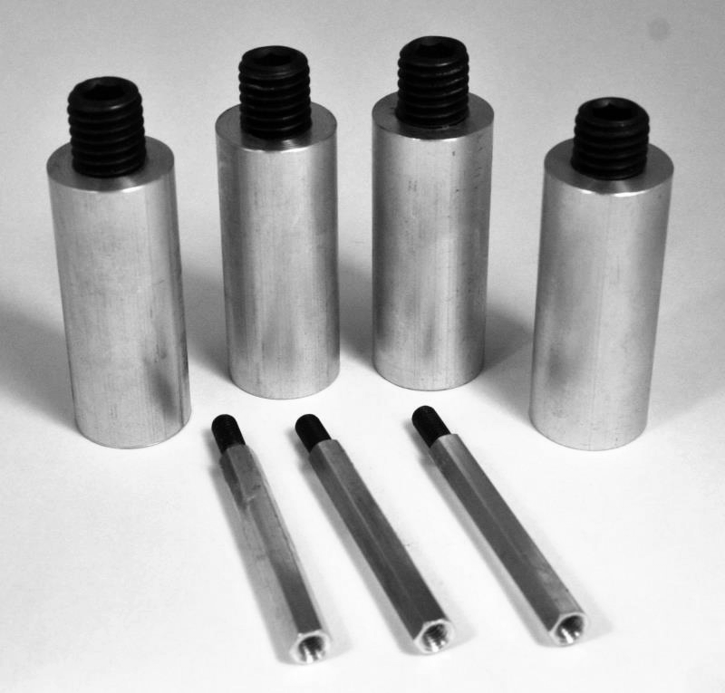

#C-S 017K +3 – C-S 3 INCH OVER-HEIGHT KIT - $80.00 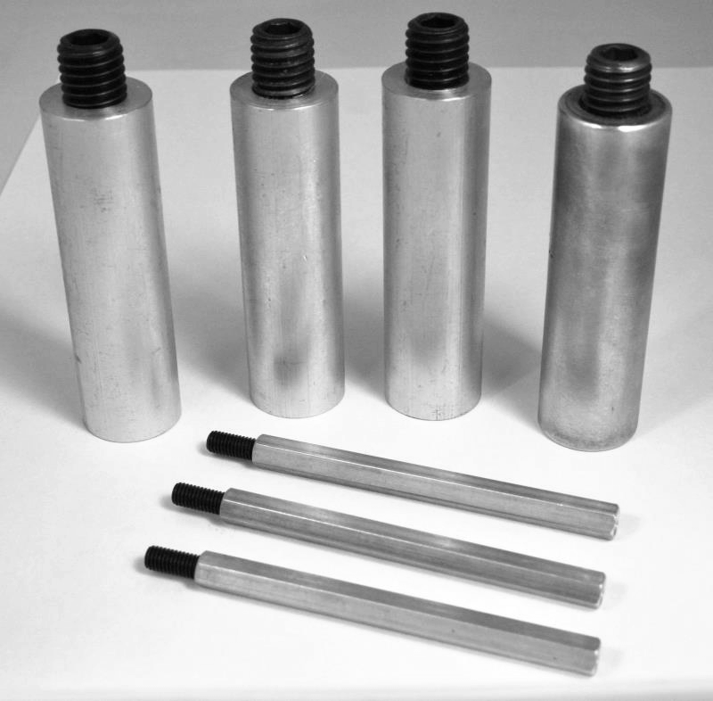

MAGNUM PARTS

#MB-050 - MAGNUM PRO-SELECT Decal - $20.00 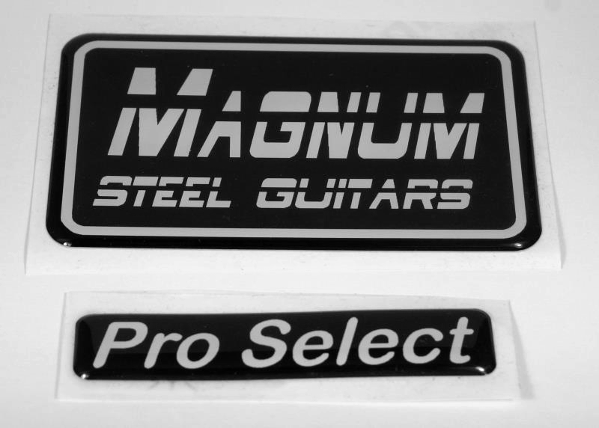

#MPKK-010 – MAGNUM PULL KIT – $46.00 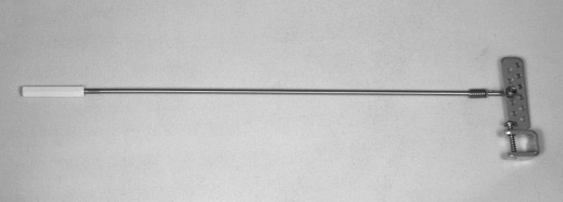
(includes Rod Puller, Pull Rod, Rod Clip, Nylon Tuner)

#MPKK-007 – MAGNUM PULL BAR ROD PULLER, 5/16” - $25.00 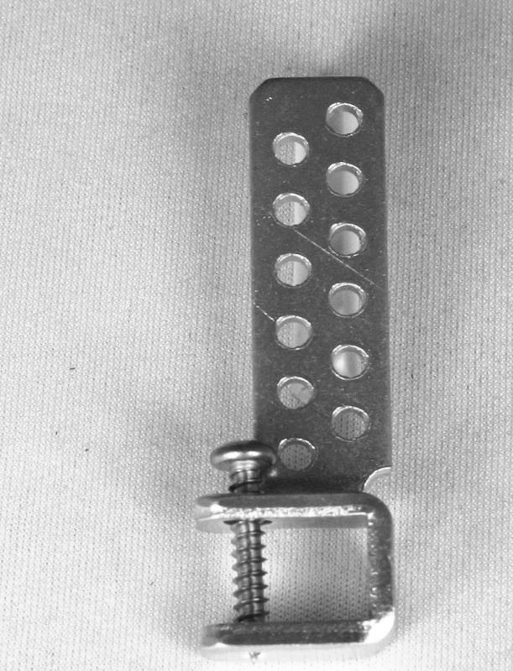

#MPKK-051 – MAGNUM 3/32 PULL ROD - $15.00

MPKK-020 – MAGNUM NYLON TUNER - $1.00 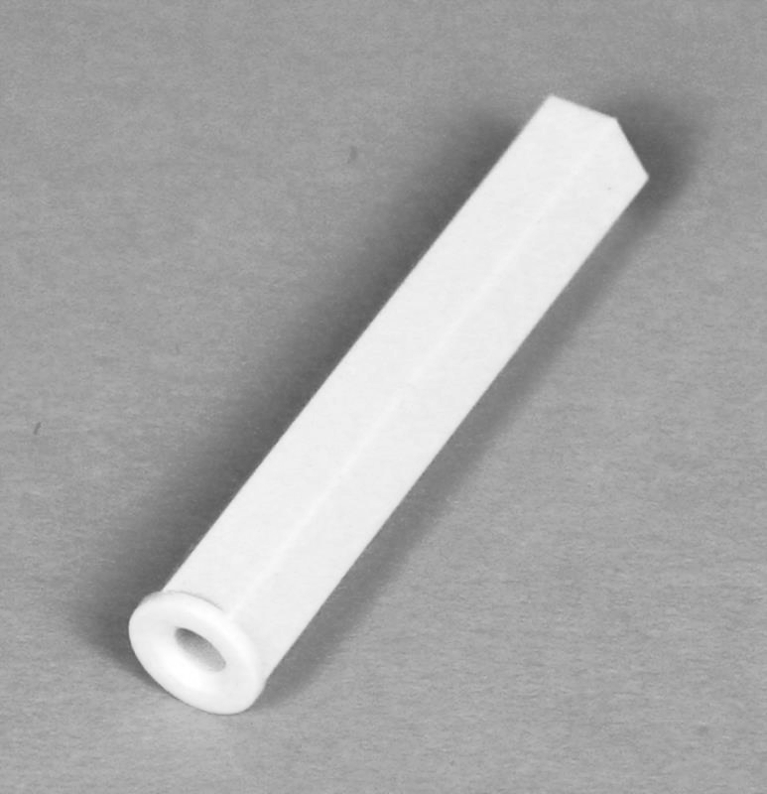
(1 ” Long for 3-32 Rod w/4-40 Thread)

#MPKK-052 – MAGNUM ROD CLIP - $5.00 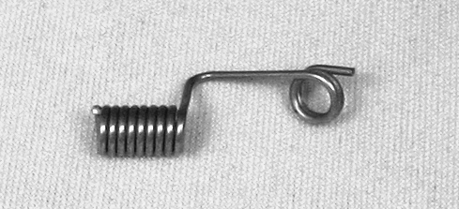

#MKLK-005-1D – MAGNUM KNEE LEVER CROSS ROD, 5/16” - $25.00
Length 9½ inches (Tip to Tip), Round Tips = ¼ inch Round, ¼ inch Long
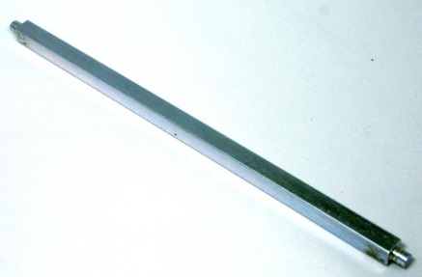

#MPK-005-1D – MAGNUM PEDAL CROSS ROD, 5/16” - $25.00 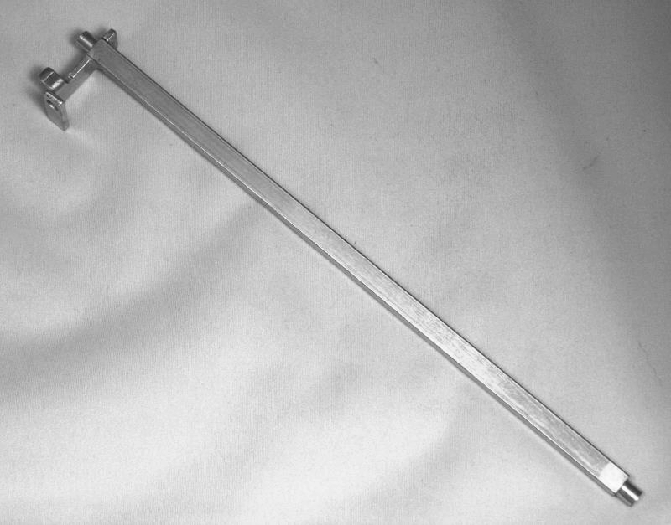
Length 9½ inches (Tip to Tip), Round Tips = ¼ inch Round, ¼ inch LongMEP -023 – MAGNUM / CARTER Coated S-10DB RT. END PLATE - $75.00 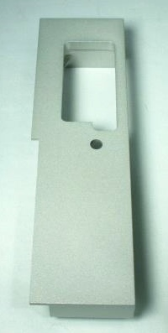 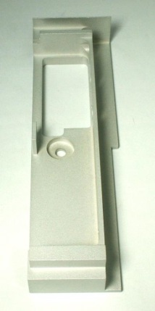 x 1 only

MEP -024 – MAGNUM / CARTERCoated D-10 RT. END PLATE - $75.00 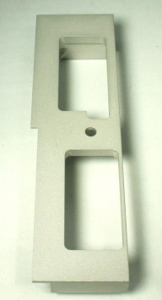 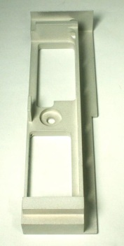 x 4 only

CARTER Pro PARTS

Body
#B-040 – Carter Po Decal - $20.00 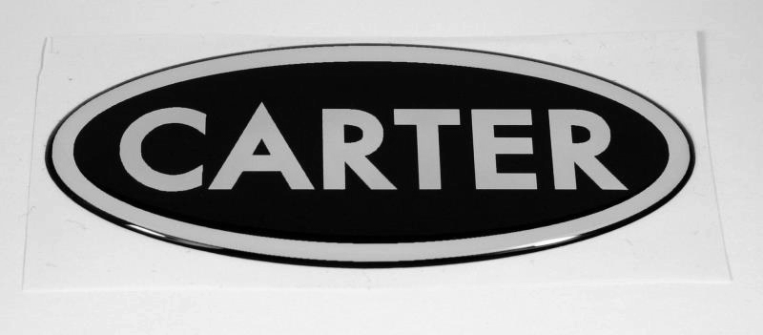

#B-017 – Single Standard Length adjustable Leg w/Rubber Tip - $50.00
Tip to tip = 26 5/8” (67.6 cm), space for pedal bar = 1 13/16” (4.6 cm) 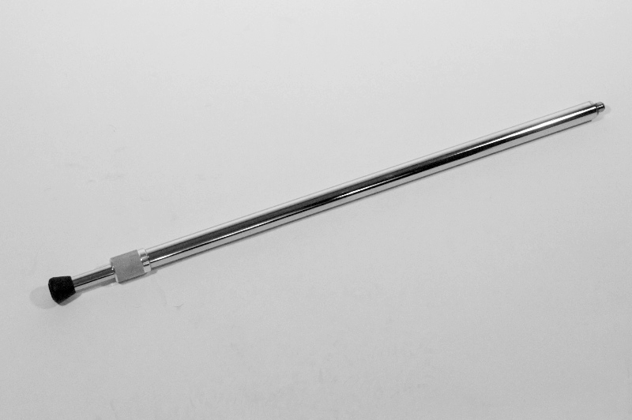

End Plates

#EP-013-2 – D-10, Left, Unpolished - $50.00 each
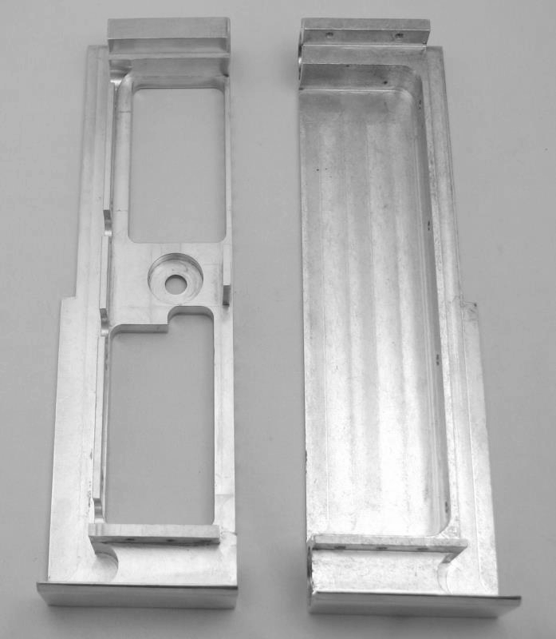 x 2 only

#EP-014-2 – S-12, Right, Polished - $100.00 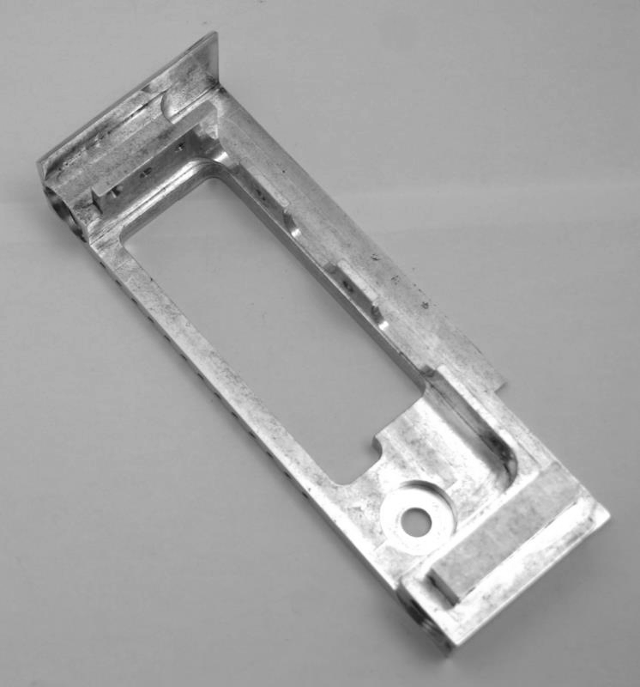 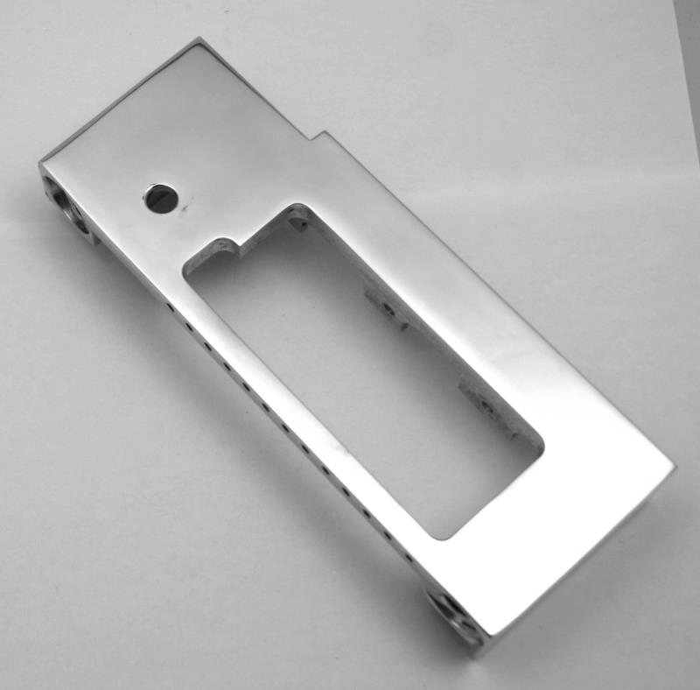 x 2 only

#EP-014-5 – S-12, Right, Unpolished - $50.00 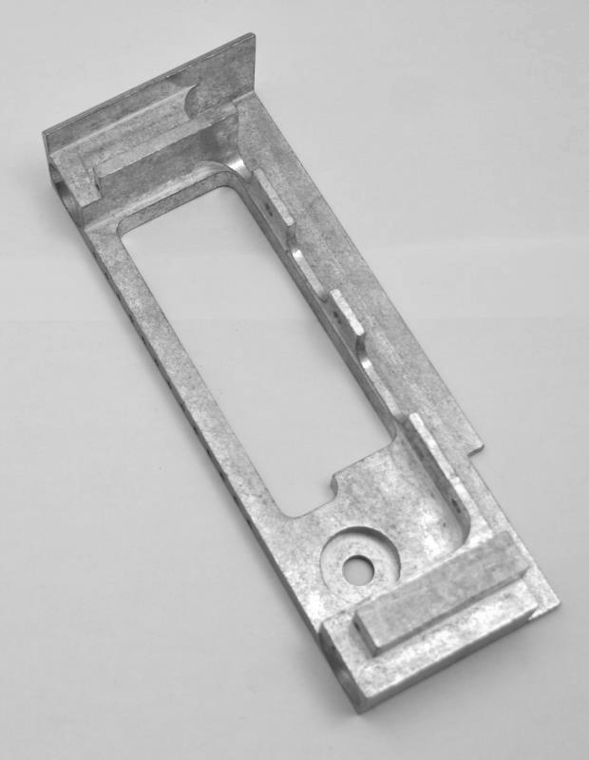 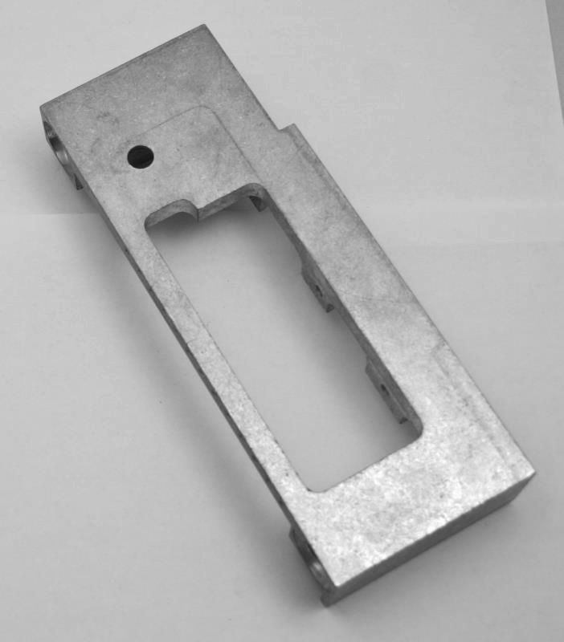 x 3 only

#EP-014-6 – D-12, Right, Unpolished - $50.00 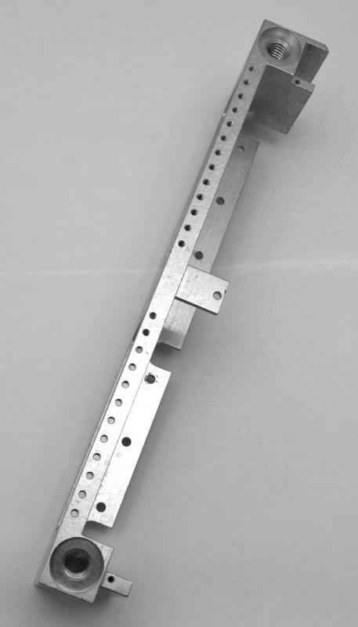 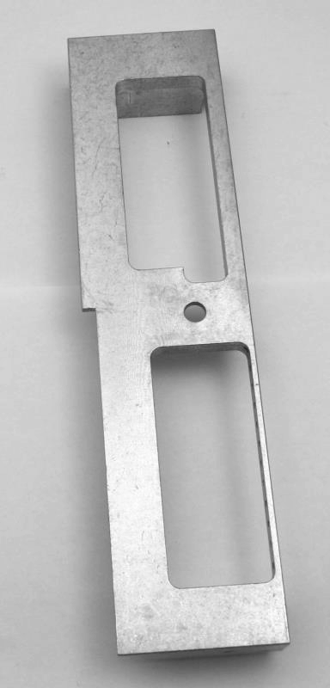 x 2 only

Pedal Bars

#PB-33 Old – 32 inch Pedal Bar, Blank, (Old Style) Polished - $100.00 (I Only)

#PB-33 Old – 33 inch Pedal Bar, Blank, (Old Style) Polished - $100.00 (5 available)

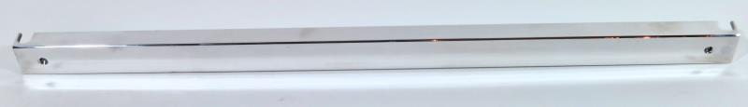
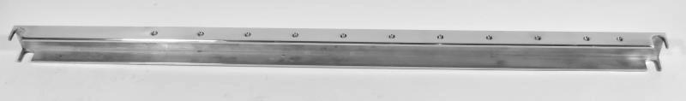

#PB-323 – 32 inch Pedal Bar, New Style, Polished - $250.00 (Extra Pedals can be added @ $50.00 ea.)

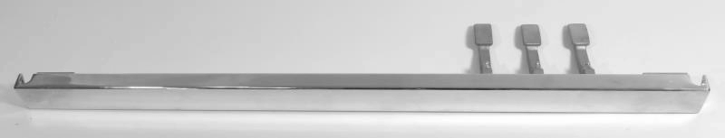
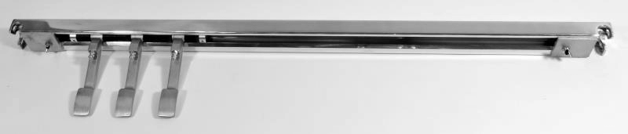

Bridge Changer Items

#BC-023 – Lower Return Spring - $5.00 each 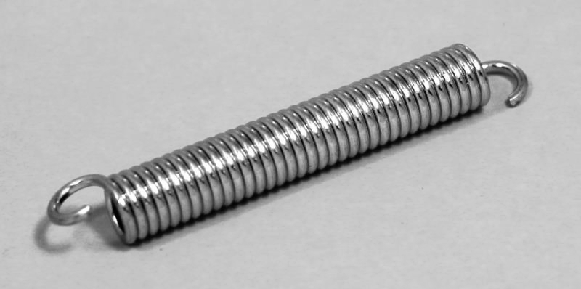

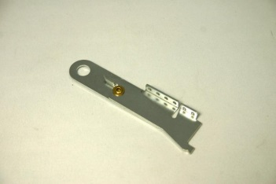

#BC-SF42 – Carter/Magnum Scissor Finger 4R/2L, 3/8 inch shaft hole - $20.00 each

Pickup Items

#PU-067 – Pickup Plate
for 10 String Wide Mount - $5.00 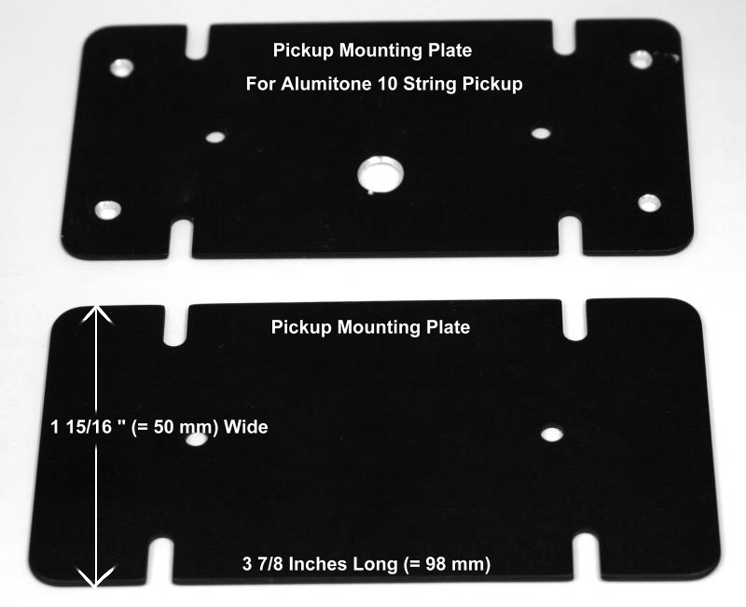

#PU-069 – Compression Spring (for mounting pickup) - $1.00 each
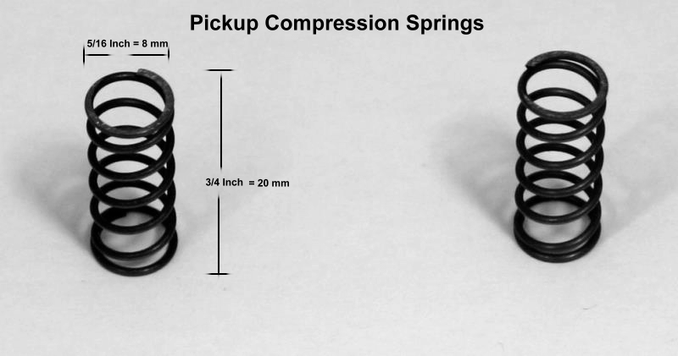

Two compression springs needed per pickup.
#PU-070 – 1/8” x 3/8” Cable Clamp - $1.00 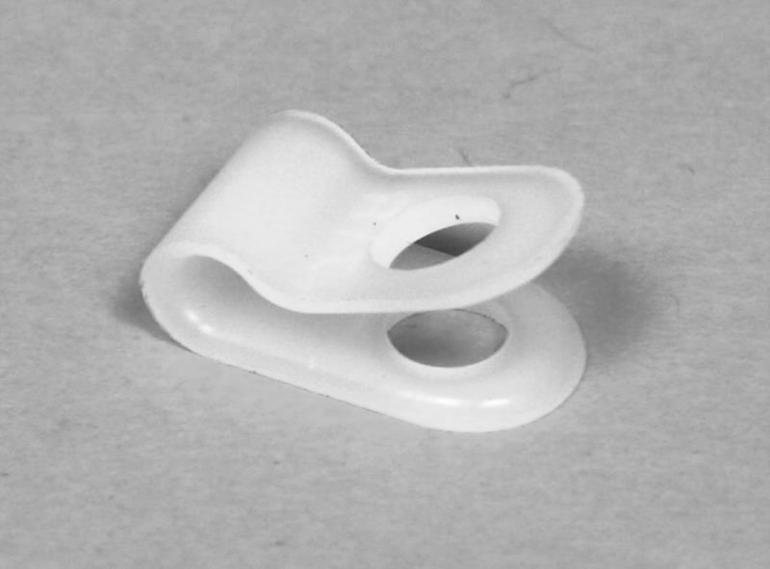

#PU-071 – Terminal Strip (used on double necks) - $5.00 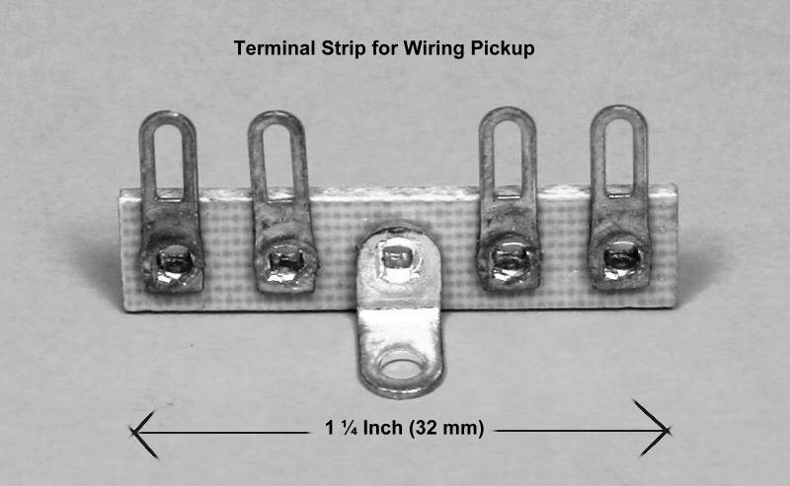

#PU-048 – DPDT (Mini) Neck Selector Switch - $20.00 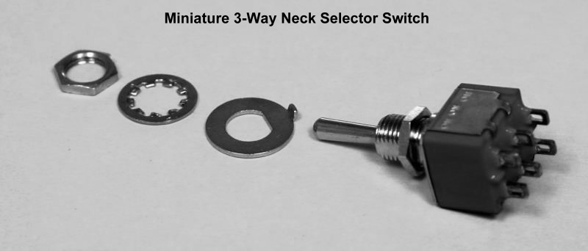

#PU-049 – Switchcraft Jack - $5.00 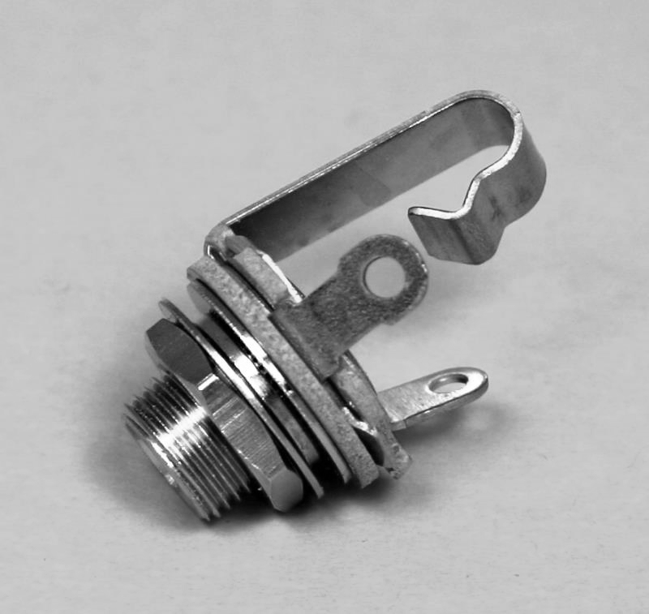

Necks

#N-037-1 – Carter Standard Neck for 10 String, Polished - $50.00 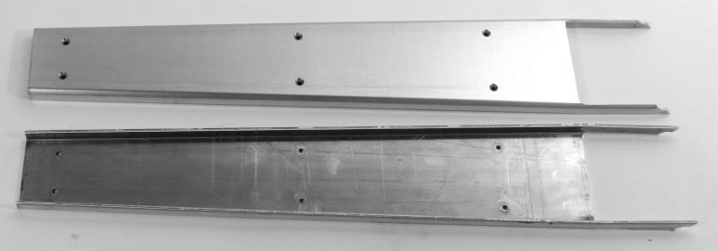

#N-037-1U – Carter Standard Neck for 10 string, Unpolished - $25.00 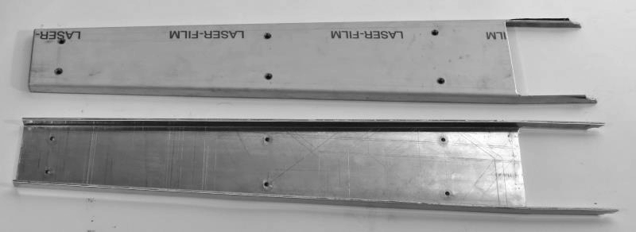

#N-037P-1 – Carter Premium Edged neck for 10 String - $100.00 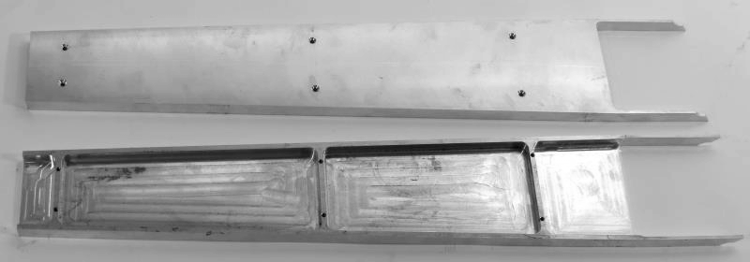

#N-037-2 – Carter Standard Neck for 12 String, Polished - $50.00 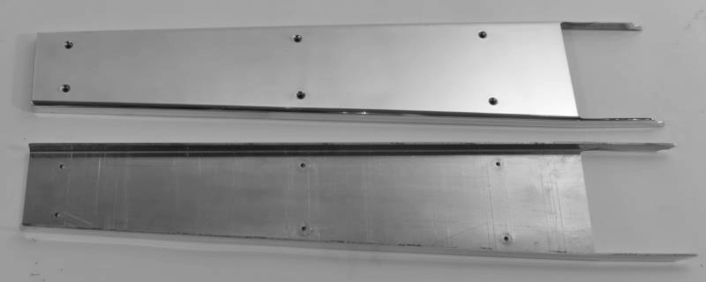

#N-037P-2 – Carter Premium Edged Neck for 12 String - $100.00 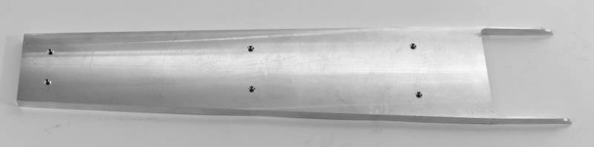
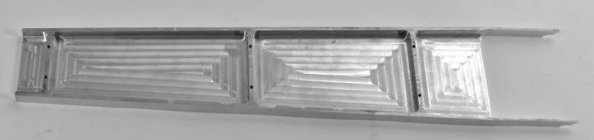

#N-039-1 – Fretboard for 10 String w/24" scale (Black & White) - $35.00
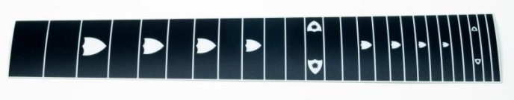
Dimensions: 18¾” L x 2¾” (Narrow/Bass end) x 3” (wide/treble end)

Keyheads

#KH-021-10 – Keyhead for 10 String w/Roller Nuts,
Satin Finish w/Sperzel Chrome Tuning Keys - $180.00 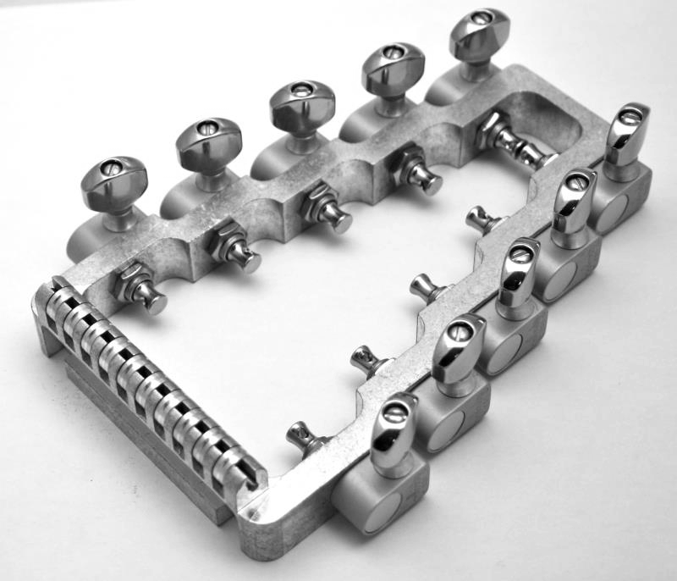 1 Only

#KH-021-1P – Keyhead for 10 String w/Roller Nuts,
Polished w/Sperzel Satin Tuning Keys - $200.00 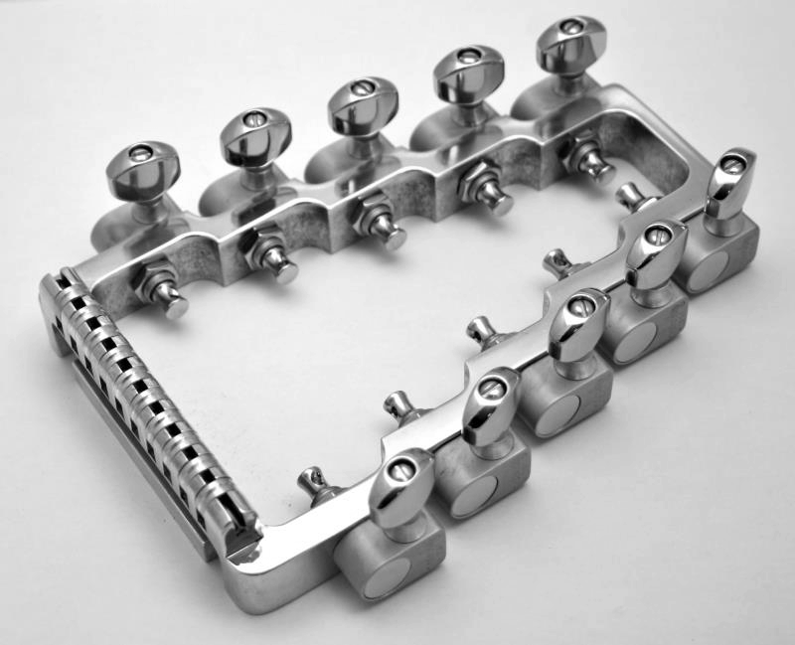 1 Only

#KH-021-1PC – Keyhead for 10 String w/Roller Nuts,
Polished, w/Sperzel Chrome Tuning Keys - $250.00 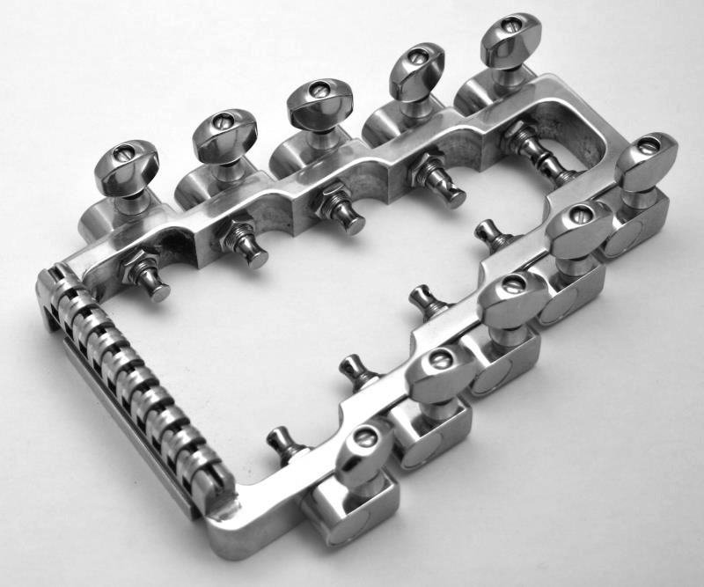 3 Only

#KH-041 – Tuning Machine – Treble, – Sperzel Satin Nickel - $10.00 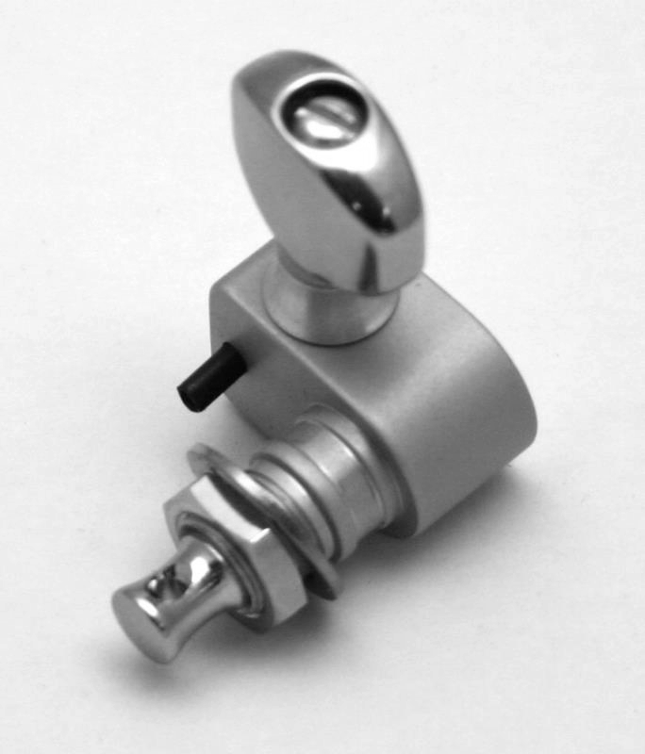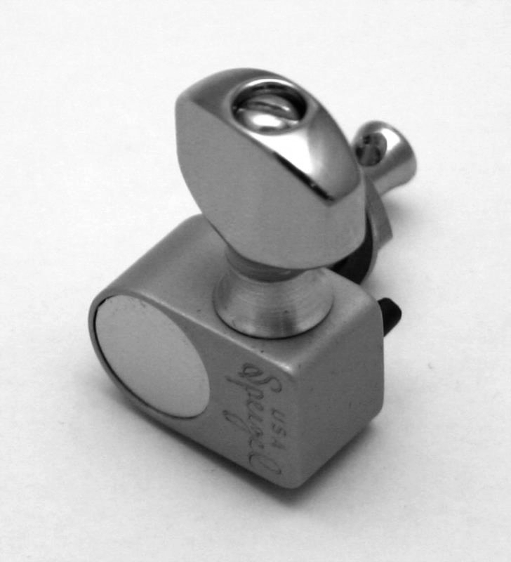

#KH – 042 – Tuning Machine – Bass – Sperzel Satin Nickel - #10.00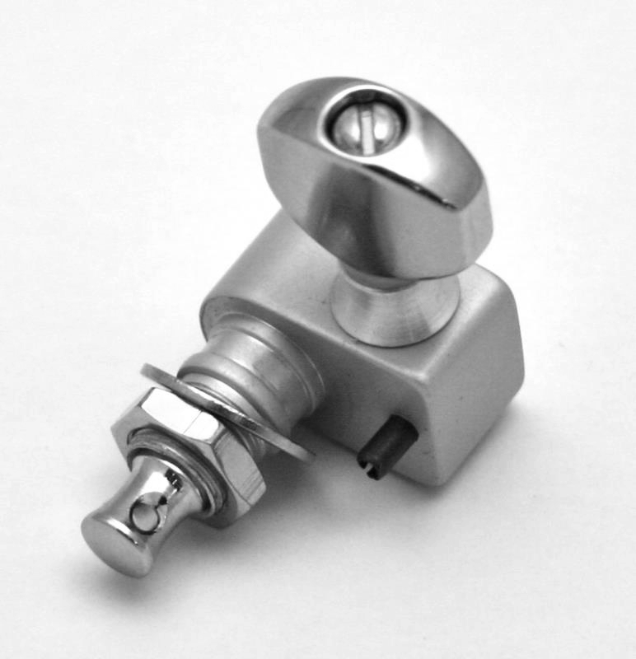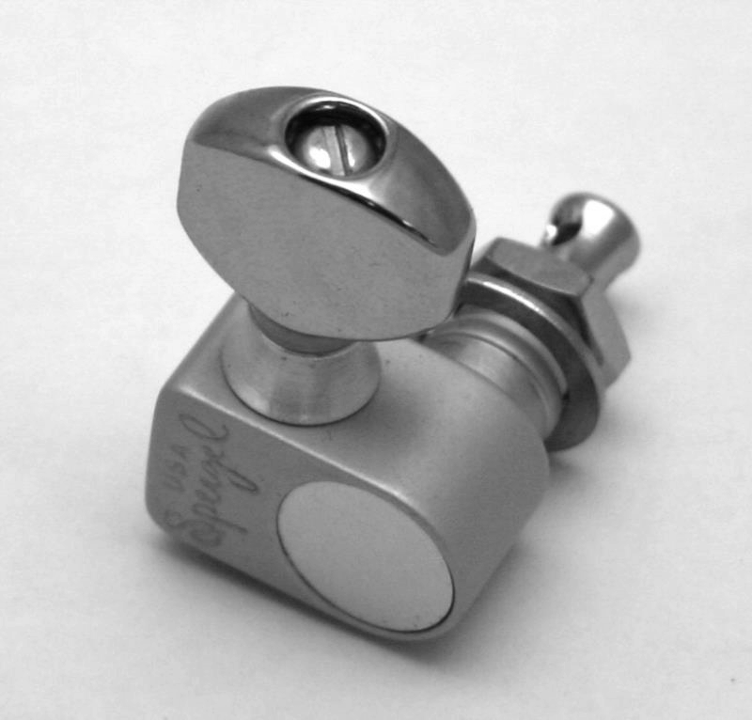

#KH-041-C – Tuning Machine – Treble – Sperzel Chrome - $10.00 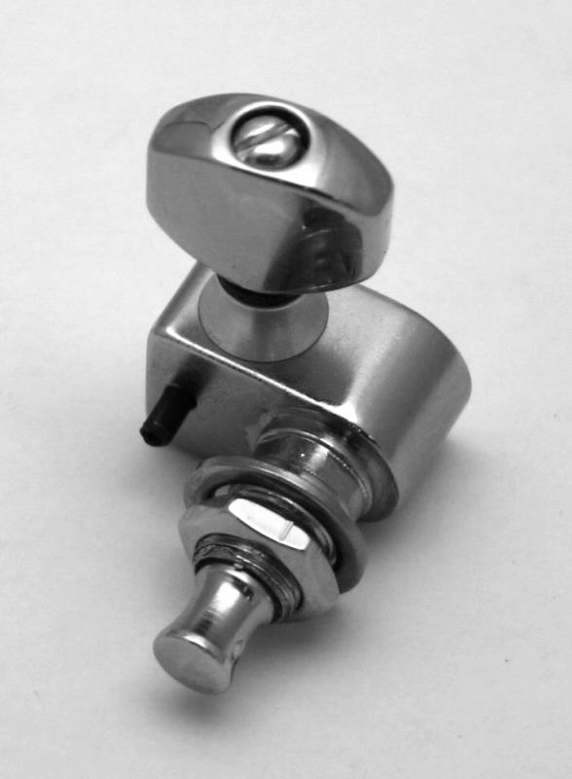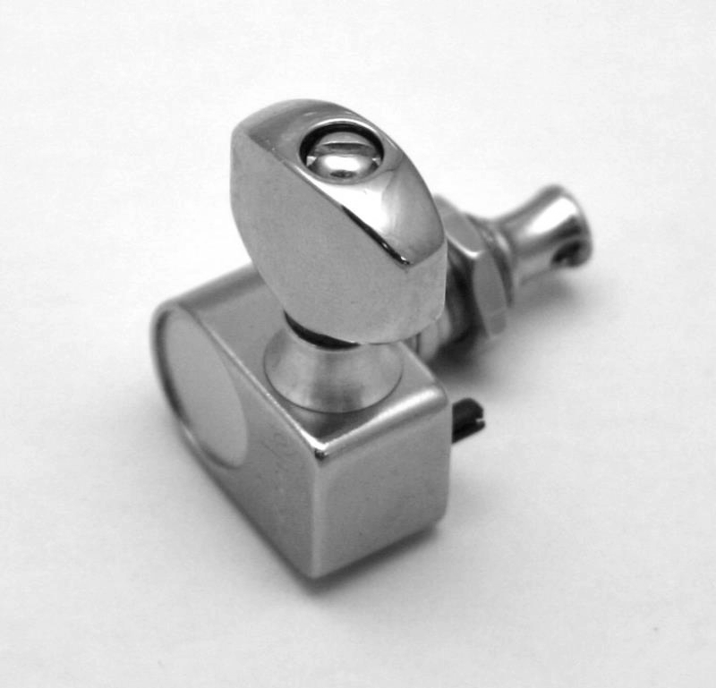

#KH-042-C – Tuning Machine – Bass – Sperzel Chrome - $10.00 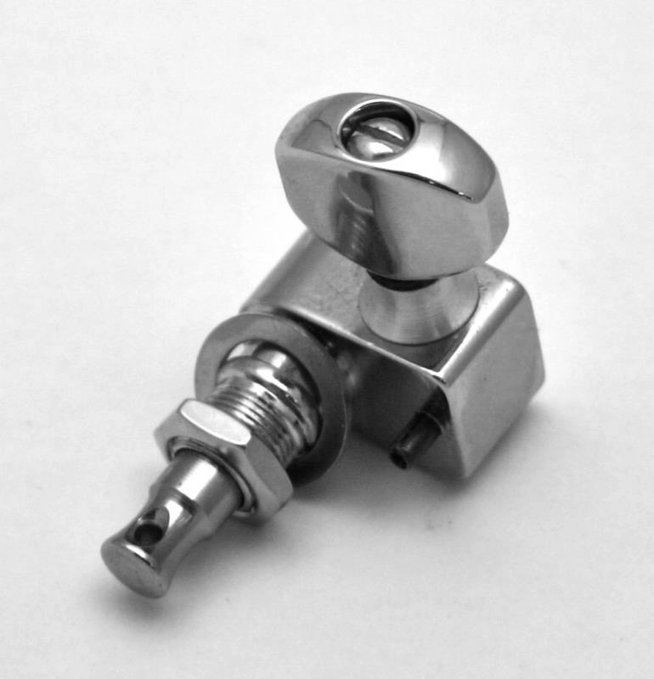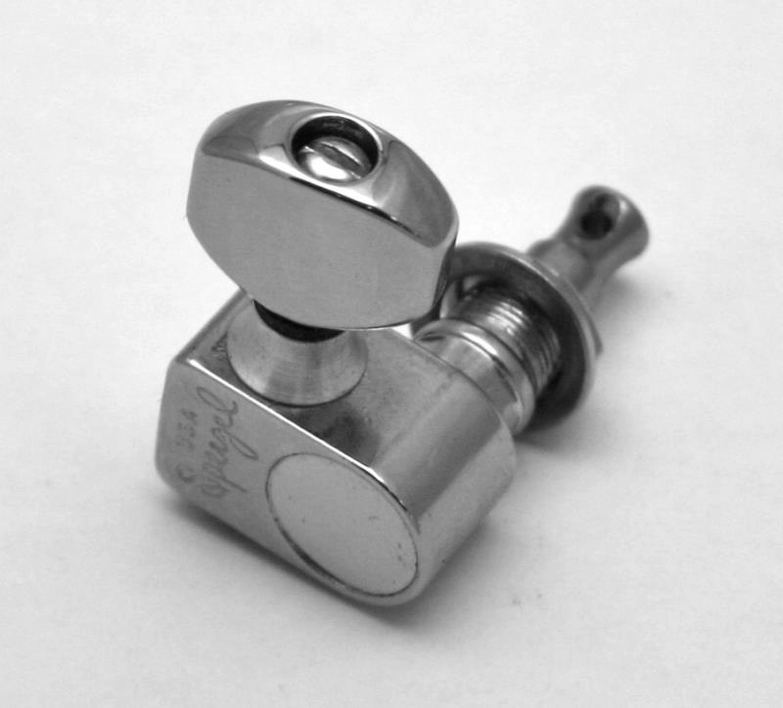

#KH-041-G – Tuning Machine – Treble – Sperzel Gold - $10.00 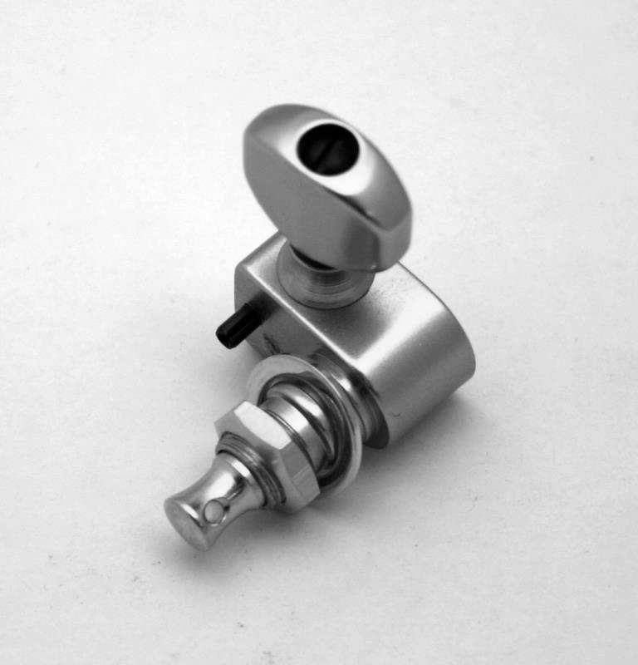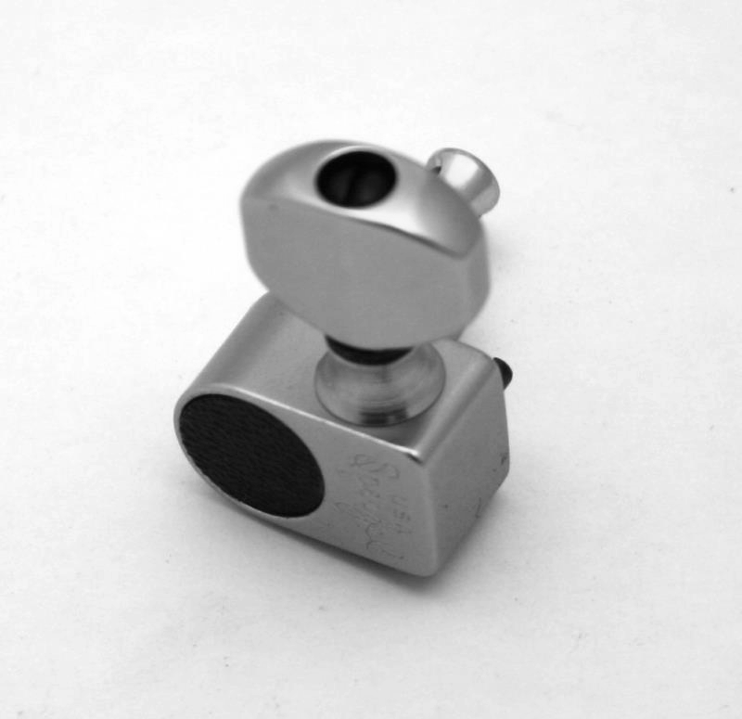

#KH-042-G – Tuning Machine – Bass – Sperzel Gold - $10.00 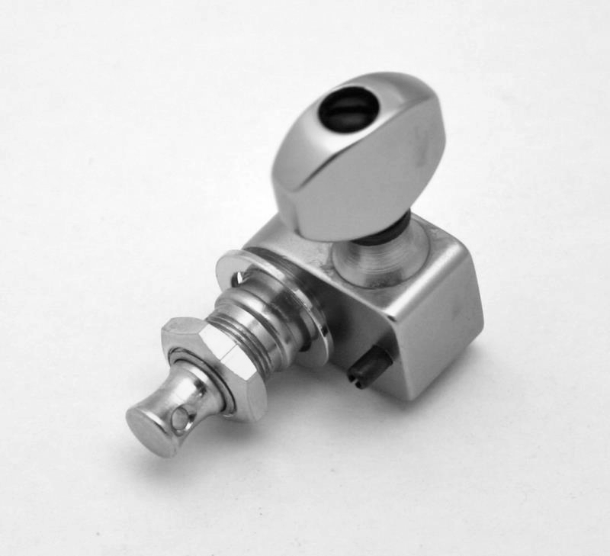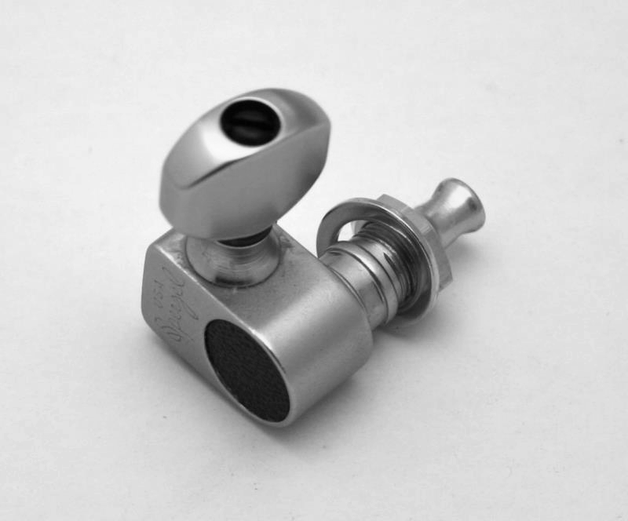

#KH-019S-1C – 10 String Roller Nut with Shaft (complete) - $50.00 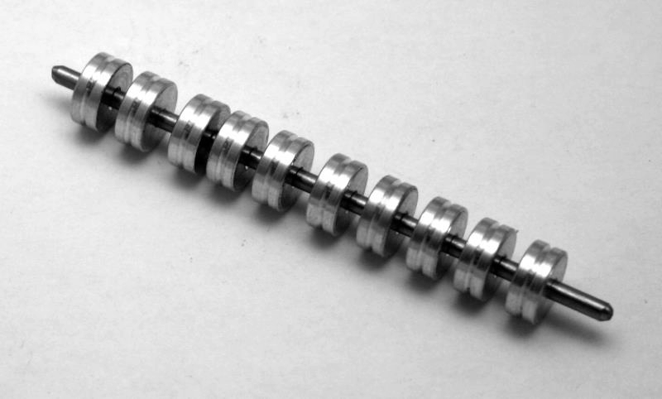

Pedal Kits
#PK-011P-N – Foot pedal – Polished New Style - $60.00 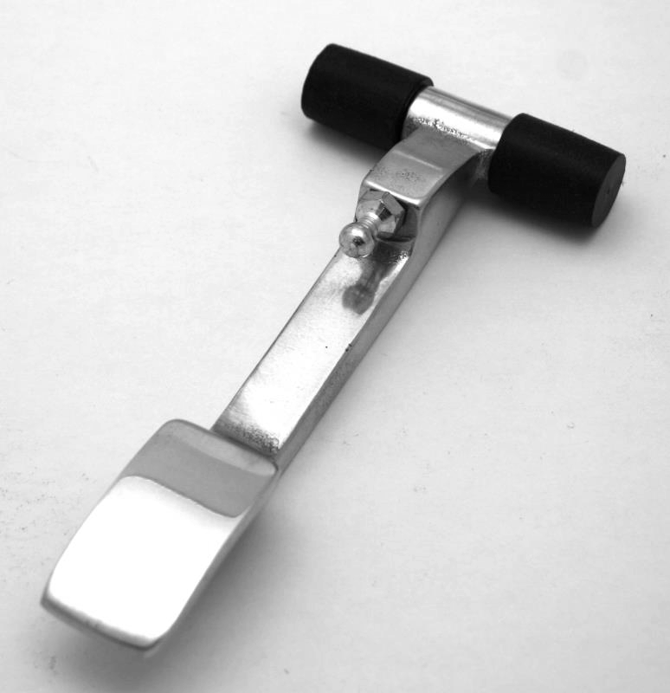

#PK-011-N – Foot Pedal – New Style (Regular) - $50.00 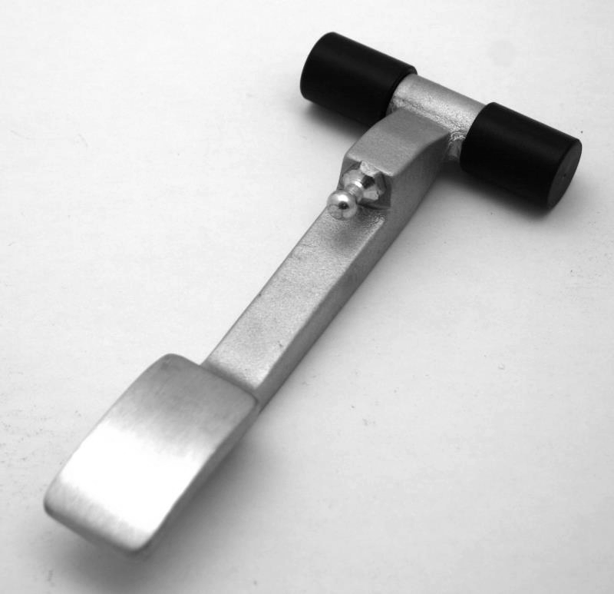

#PK-022 – Pedal Pull Rod, 10-32 Thread - $15.00 (Specify length)
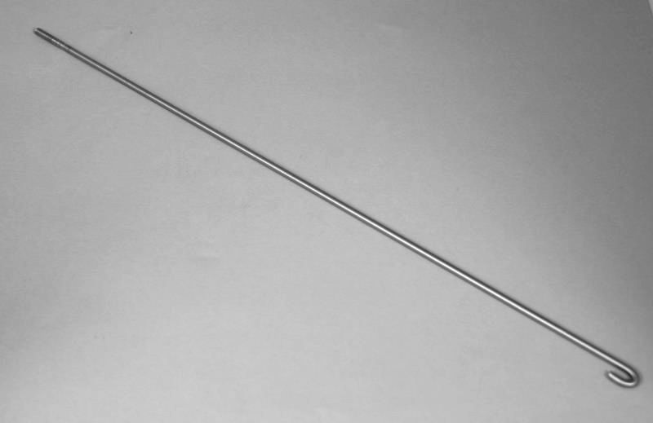

#PK-078 – Pedal Rod Number Stickers - $10.00 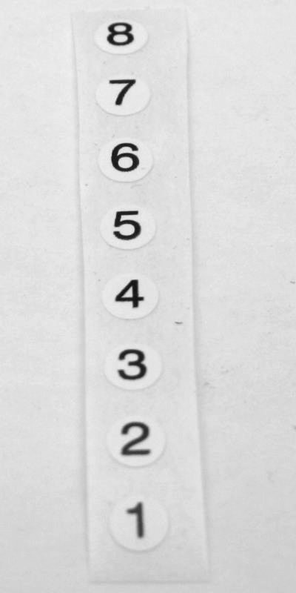

#PK-005 – Pedal Cross Rod, 7 inches (Tip to Tip), Round Ends = ¼ inch round, ¼ inch long
(Carter S-10 & S-12 Pedal Cross-Shaft, 3/8 inch square) - $30.00
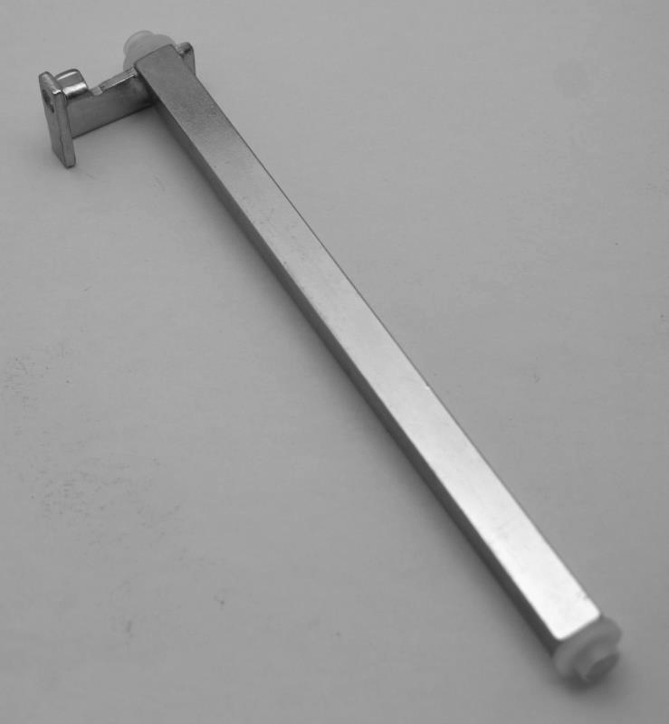

#PK-005-1D – Pedal Cross Rod, 9½ inches long, Round Ends = ¼ inch Round, ¼ inch Long
(Carter D-10, S-10DB String Pedal Cross-Shaft, 3/8 inch Square) - $30.00
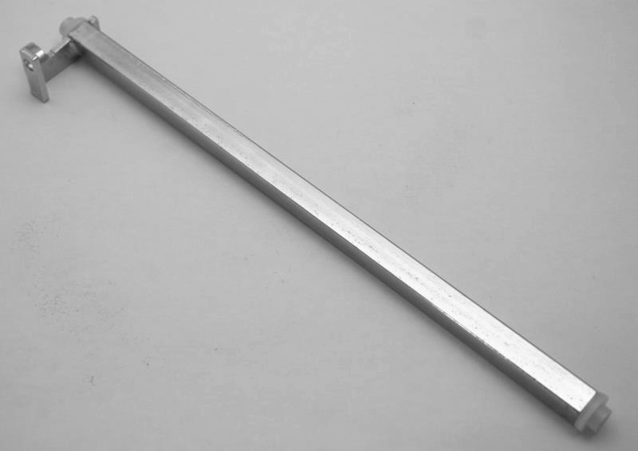

#PK-081 – 1 inch Pedal Rod Extenders, 10-32 thread - $10.00
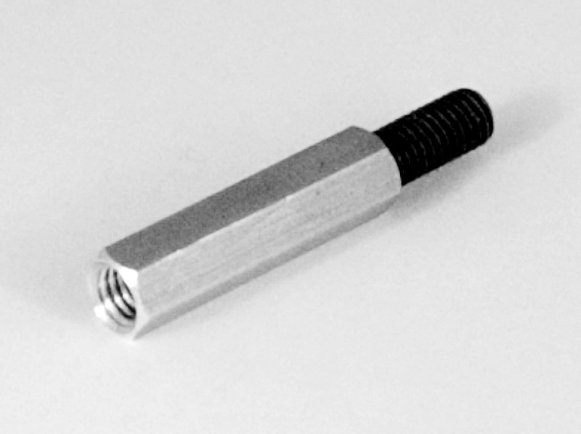

#PK-082 – 2 inch Pedal Rod Extenders, 10-32 thread - $10.00
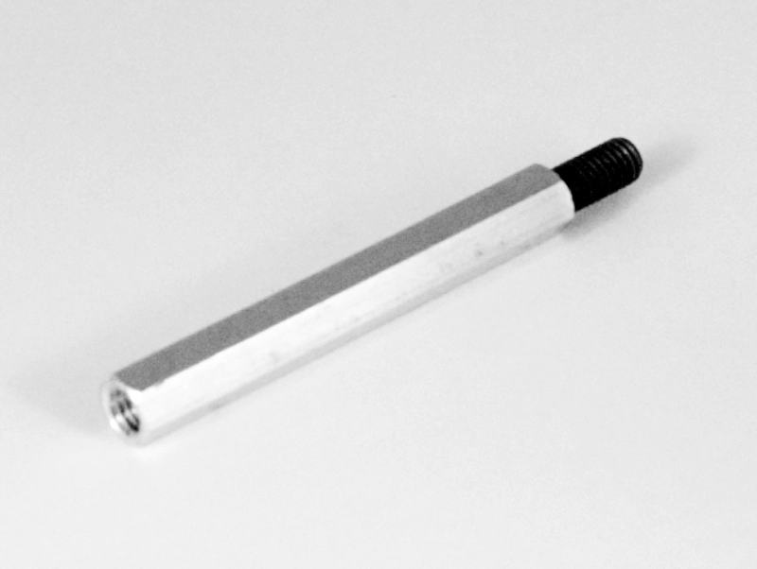

#PK-083 – 3 inch Pedal Rod Extenders, 10-32 thread - $10.00
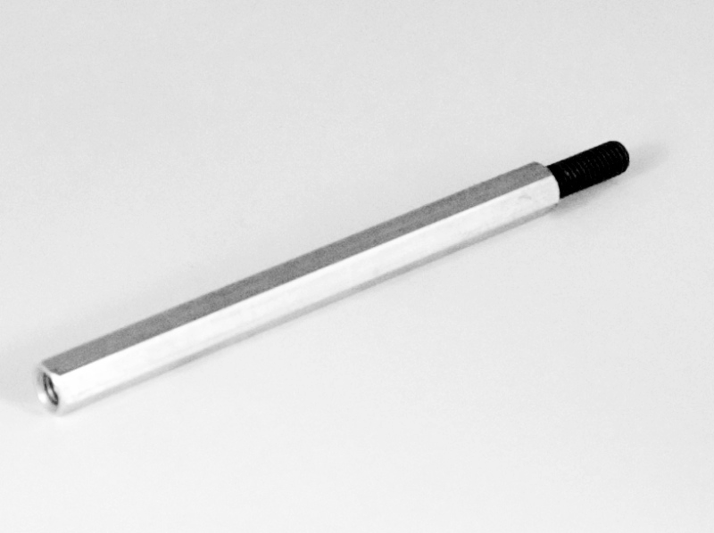

Knee Kits
#KL-087 – Knee Lever Mounting Bar - $25.00 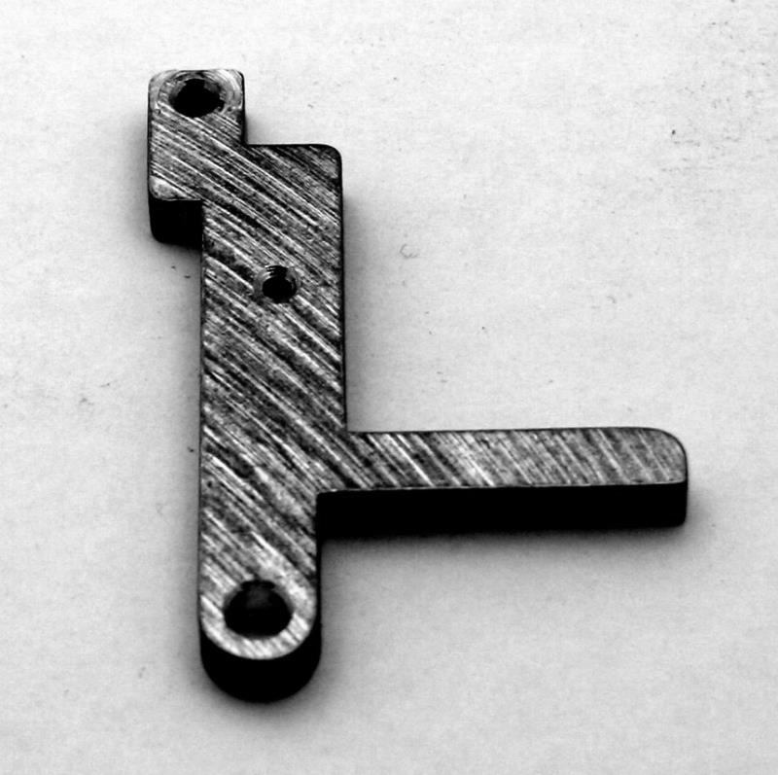

#KL-088 – Knee Lever Reversing Bar (LKR & RKR) - $20.00 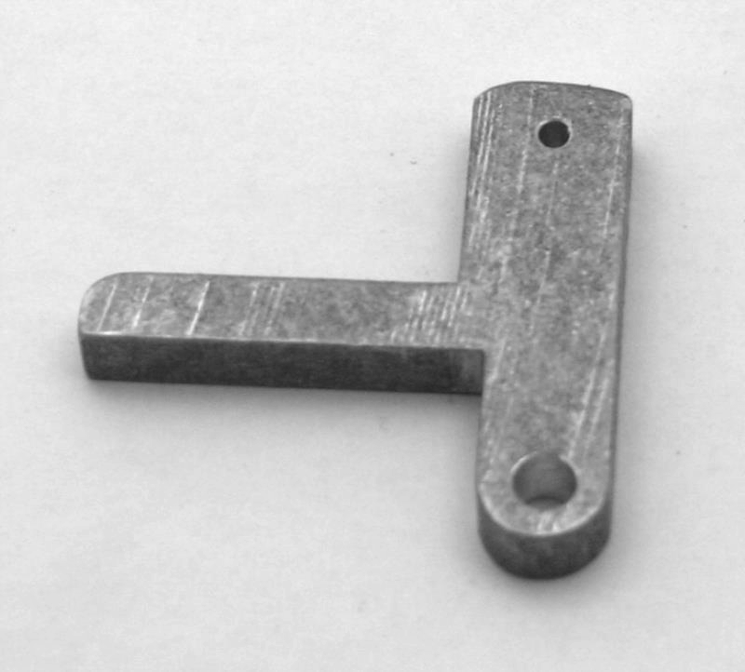

#KL-008 – Knee Lever Cross Rod (Cross Shaft) & Carter S-10, S-12 Gear-Down Cross-Shaft
3/8 inch Square x 7 inches long (Tip to Tip), Round Tips = ¼ inch Round, ¼ inch Long - $30.00 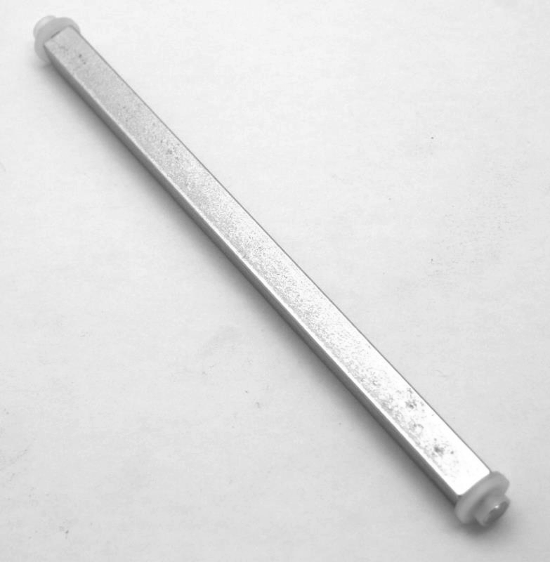

#KL-008-1D – Knee Lever Cross Rod (Cross-Shaft) & Carter D-10, S-10DB Gear-Down Cross-Shaft, 3/8 inch Square x 9½ inches long (Tip to Tip), Round Tips = ¼ inch Round, ¼ inch Long - $30.00
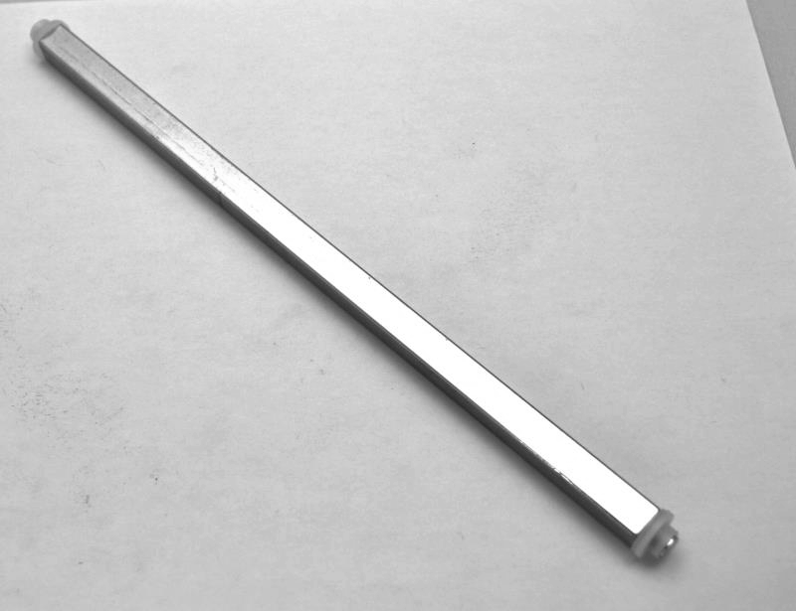

#KL-LKL-Mod – LKL Module - $125.00
(can be used with most any Pedal steel)
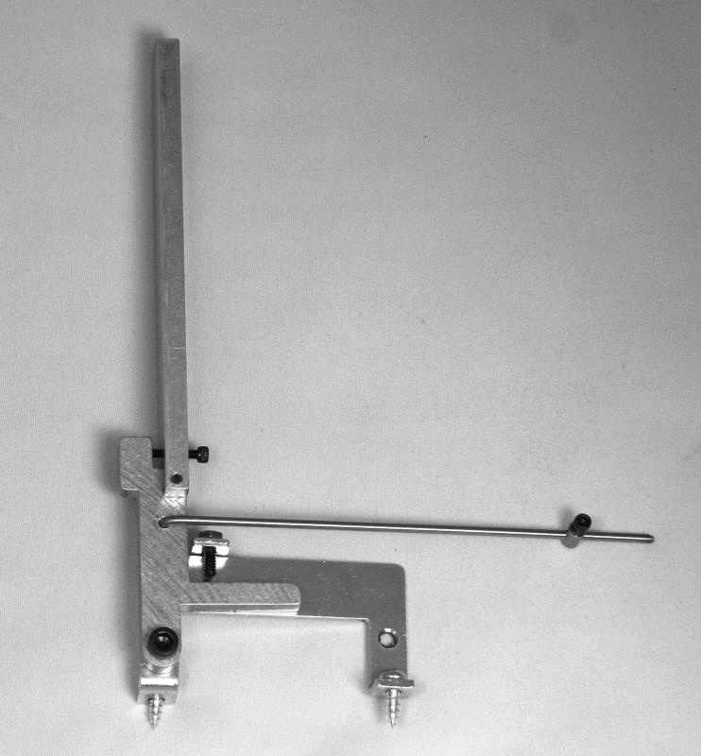

#KL-LKR-Mod – LKR Module - $125.00
(can be used with most any pedal steel)
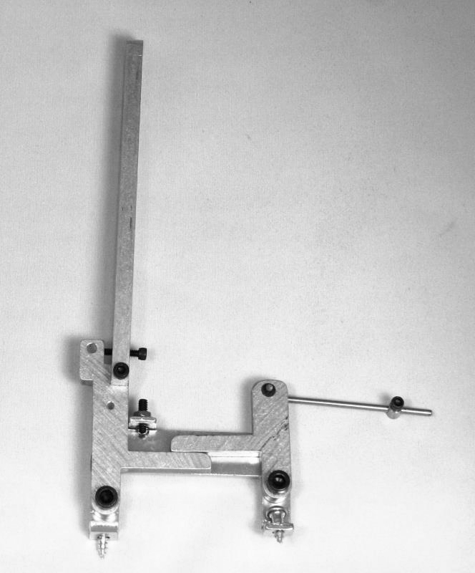

#KL-LKV-Mod – LKV Module – $125.00
(can be used with most any pedal steel)
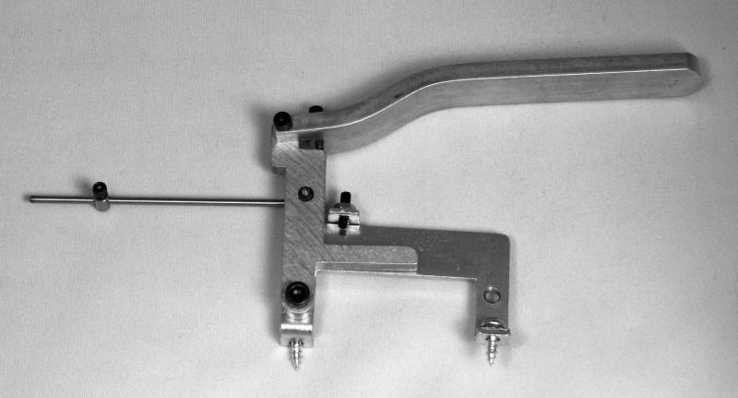

#KL-RKL-Mod – RKL Module - $125.00
(can be used with most any pedal steel)
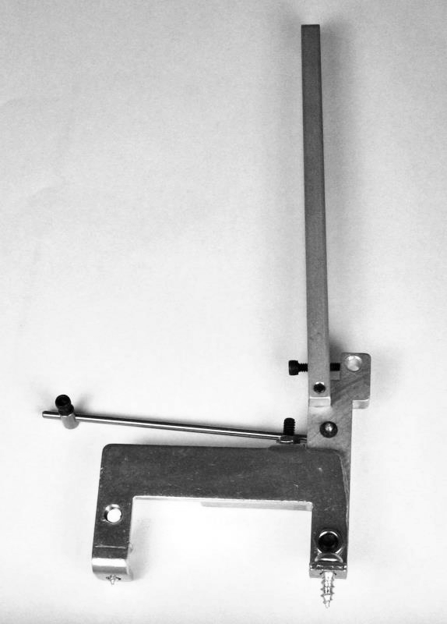

#KL-RKR-Mod – RKR Module - $125.00
(can be used with most any pedal steel)
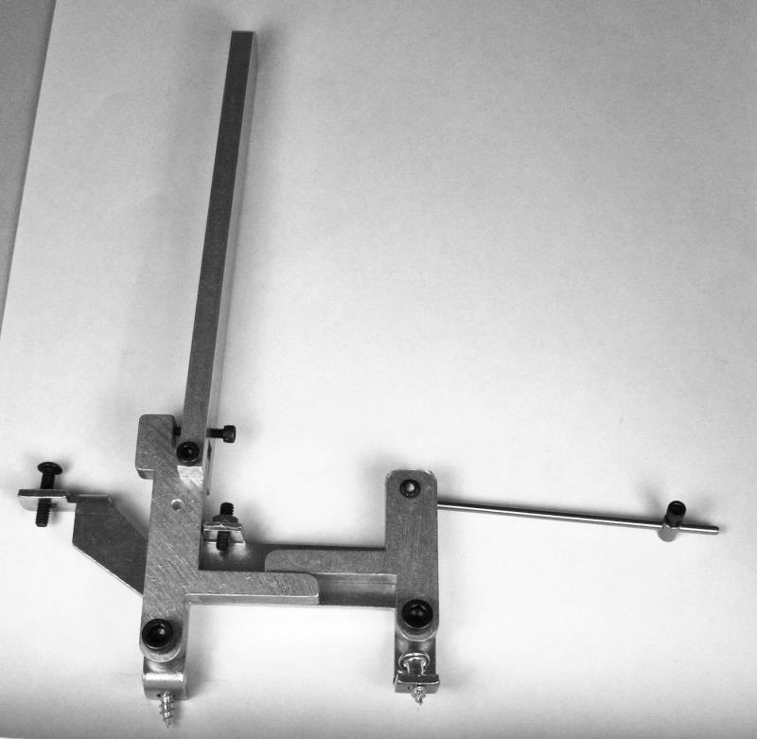

Carter complete Knee Kit (please specify model) - $200.00

[ Includes KL Module, Cross Bar (Cross Shaft), 2 x Pull Bars (Rod Pullers) w/Torx screws, 2 x Pull Pins, 2 x Pull Rods, 2 x Nylon Tuners, & Nylon Silencers (if needed). ]

Pedal & Knee Kits
(Items used for both Pedal & Knee Kits)
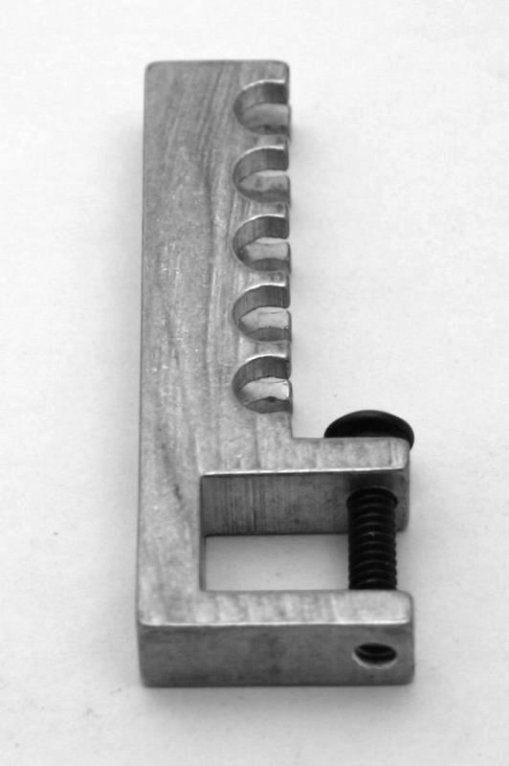
#PKK-007 – Pull Bar (Rod Puller) w/Torx Screw - $25.00

#PKK-099 – 6-32 x 5/8” Button Head Torx Screw
(for securing Pull Bar [Rod Puller] to Cross-shaft - $1.00 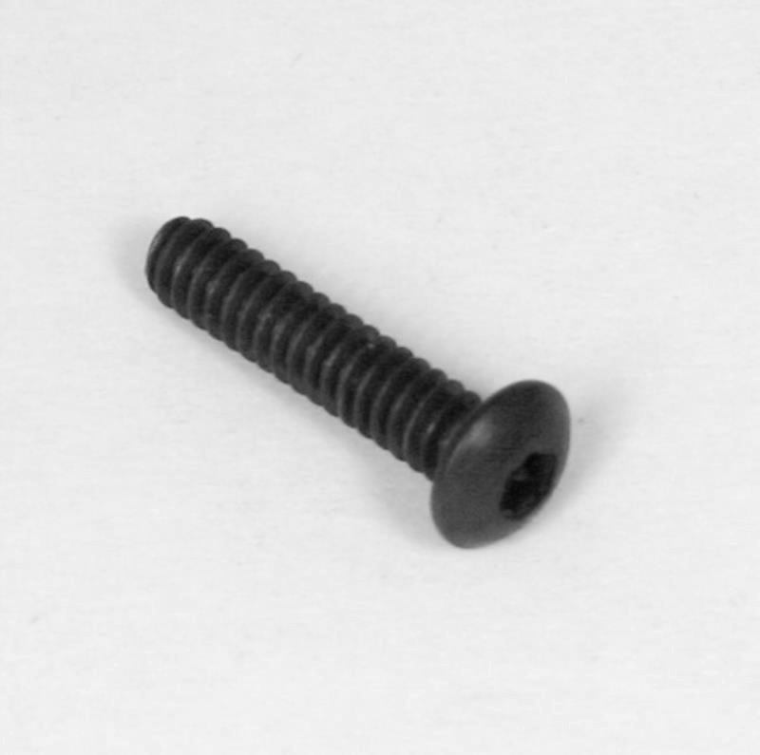

#PKK-027 – Pull Pin (Brass Dog Bone) - $5.00
(Inserts into slots in Pull Bar [Rod Puller] around which Pull Rod hooks)
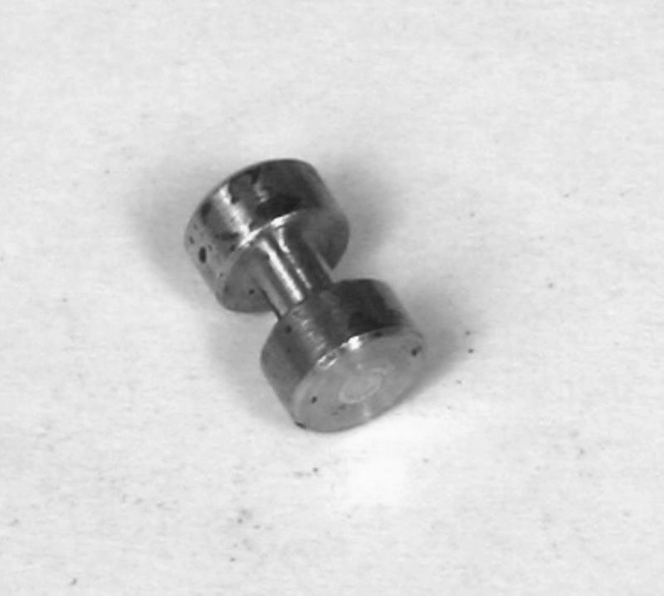

#PKK-033 – Nylon Guide for Pull Rod
(used as silencers for Pull Rods) - $2.00 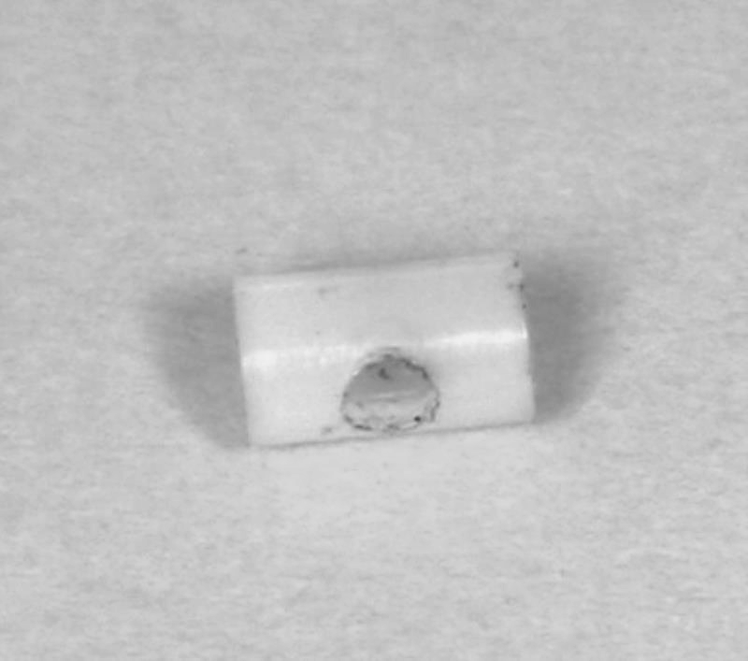

#PKK-052 – Barrel Nut (Brass Collar) with 4-40 x ¼” Socket Cap Screw
(used with Gear-Down, & KL Push/Pull Rods, & Pull Rods in lieu of Pull Pins) - $10.00
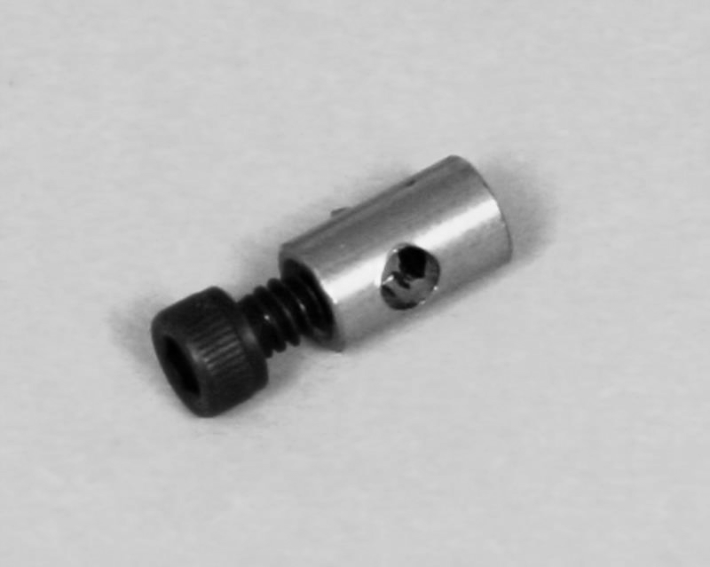

#PKK-101 – Nylon Spacer for Cross-Shafts (to eliminate slack (play) in cross-shaft)
(¼” I.D. x .032” thick x ½” O.D.) - $1.00 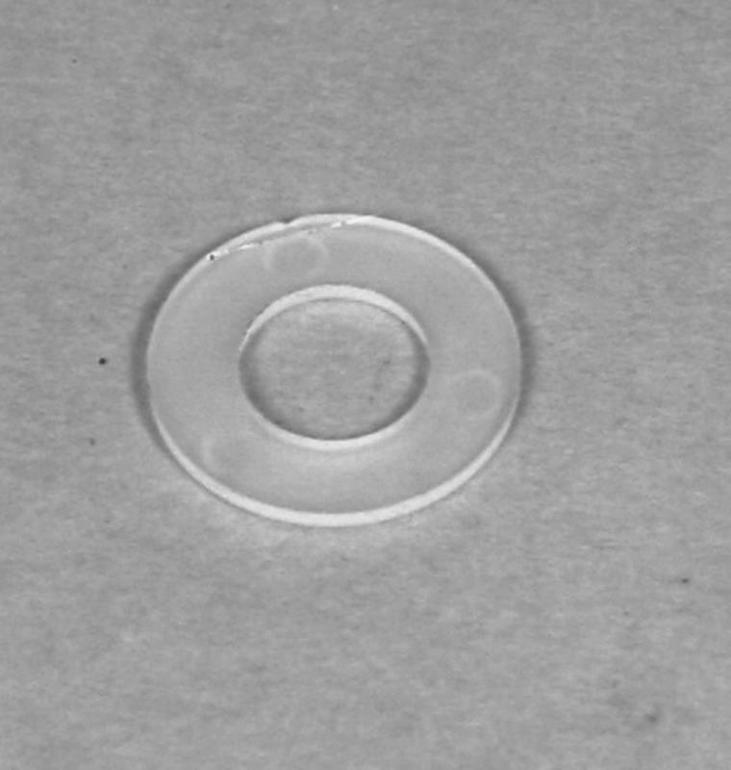

#R-001 – Nylon Shoulder/Washer Bushing, ¼-12,
(used in Carter Front Rail/apron) to mount Cross-Shafts - $1.00 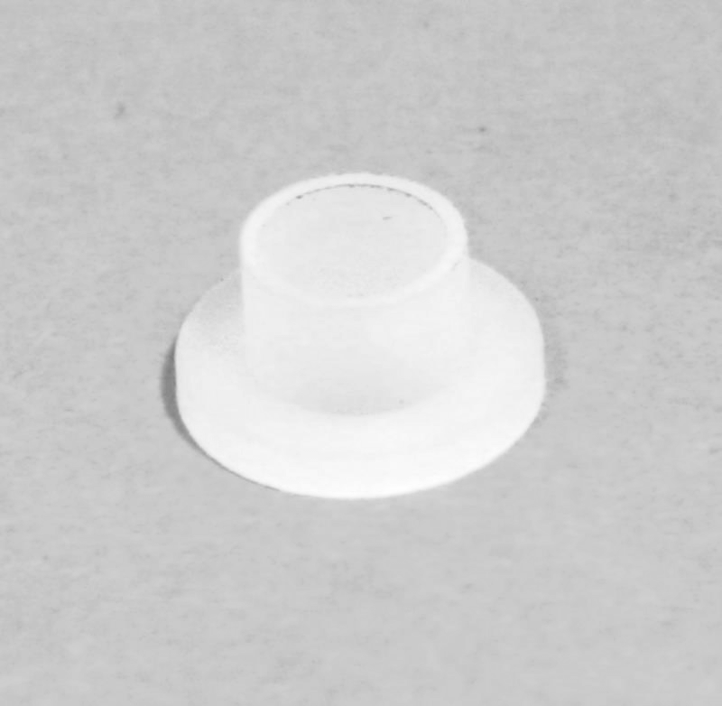

#R-005 - Nylon Shoulder/Washer Bushing, ¼-8,
(used in Carter Rear Rail/apron) to mount Cross-Shafts - $1.00 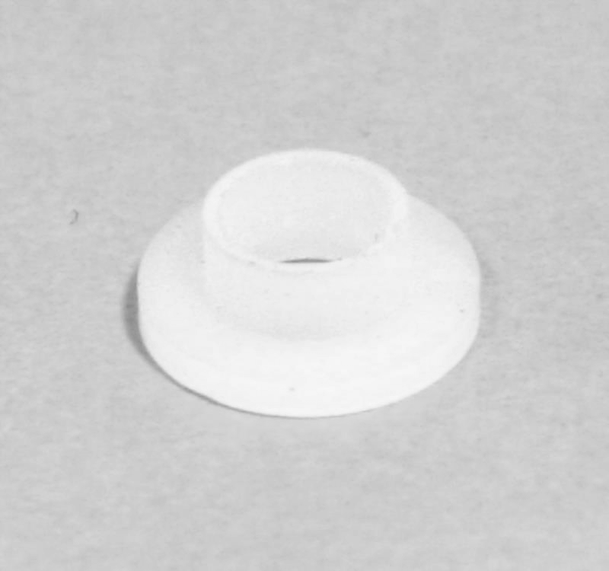

#PKK-020 – Nylon Tuner Nut, 1” for 3/32 Pull Rod - $1.00

#PKK-051 – Pull Rod, 3/32 Diameter
(specify which pedal or knee lever for which it is required, (or measurement),
as we will put the hook bend in it to fit purpose) - $15.00

Volume Pedal Parts

#VP-RTM – Rubber Tread Mat for Volume Pedal
(3¼” x 10” with peel-off sticky back) - $5.00 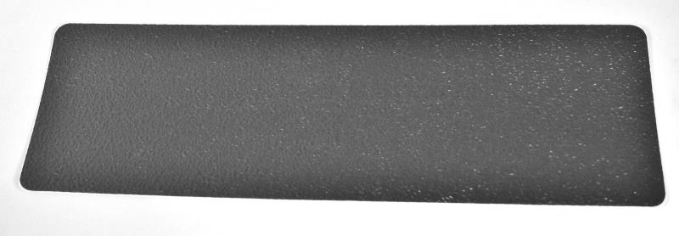

#VP-RF – Rubber Feet
(strip of 4 with peel-off sticky back) - $1.00 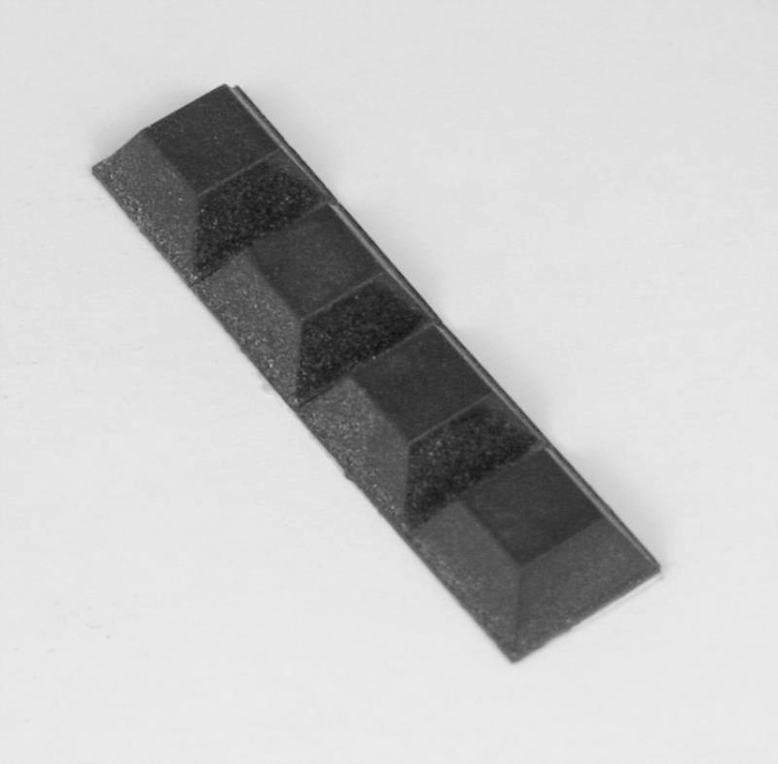

#VP-Pulley – Pulley for Volume Pedal with 8-32 socket set screw
(fits over ¼” shaft of pot, ¾” long) - $10.00 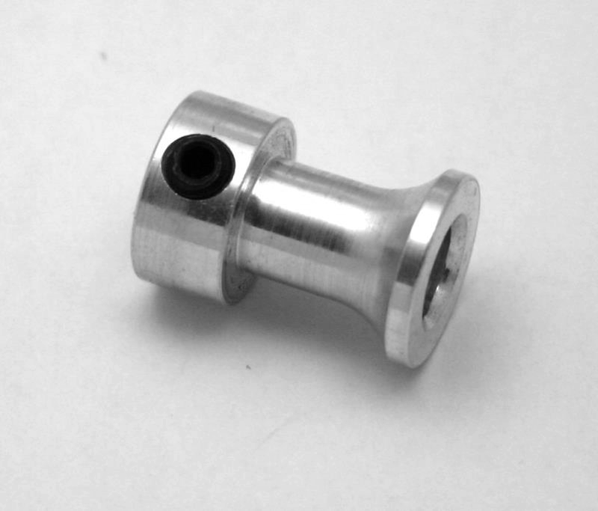

#VP-Spring – Spring for Volume Pedal
(1¼” x ¼”) - $1.00 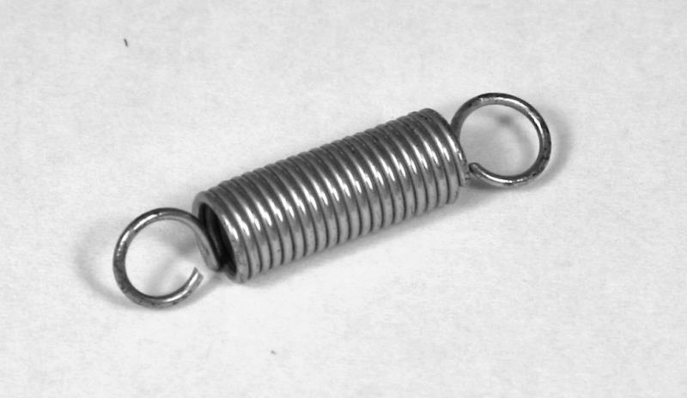

To Order

Send an e-mail c/o steelcan@steelguitarcanada.com

-(or phone) with your requested items;
(Toll Free Order Line, 1-877-673-6394 Canada & USA)

-(or mail) using the Order Form on the last page;

(Remember…there is a $40.00 product minimum on mail orders)

We need your address & phone # to obtain a shipping quote, then we can get back to you with the postal shipping options & any applicable taxes.

We will then need to determine method of payment…Visa, MasterCard, Money Order, Interac e-transfer Bank Transfer (Canada Only), etc.

Regarding Postal Shipping

There is a $40.00 product minimum on mail orders because it costs about as much to ship a $20.00 order as it does a $60.00 to $80.00 order (depending upon items), & takes just as much paper, ink, & time to process.
It is more economical to ship items under 30 Kg (66 lb) via the post office. Courier shipments (UPS, FedEx, etc.) across international borders incur brokerage fees of app. $30.00+ in addition to freight costs.
Since COVID-19 shipping rates have increased app. 20 to 30%.

Applicable Canadian taxes are extra on sales within Canada.
No Canadian tax is charged on ‘out of Canada’ shipments.
Thanks, Al Brisco

Servicing the Steel Guitar Market since 1979
Our Business Is NOT A Hobby!

~Your Premium Steel Guitar Source~
Steel Guitars of Canada
566 Dudley Rd.,
Colborne, ON K0K 1S0
Ph: 905-355-3056
E-mail: steelcan@steelguitarcanada.com
Web Site: www.steelguitarcanada.com

STEEL GUITARS OF CANADA

ORDER FORM
Name___________________________________ |  |  |  | Address_________________________________
Town/City________________________________ |  |  |  | Prov./State_____ Postal Code____________
Country _________________________________ |  |  |  | E-Mail: __________________________________
Phone (_____)____________________________ |  |  |  | Mobile:__________________________________
ITEMS ORDERED:
Quantity |  |  | Description |  |  | Amount
 |  |  |  |  |  | $
 | 1st Sub-Total |  |  |  |  | $
 | Shipping Charges (Minimum of $5.00, see Instructions for additional details) |  |  |  |  | $
 | 2nd Sub-Total |  |  |  |  | $
 | Residents of Ontario add 13% H.S.T. |  |  |  |  | $
 | Residents of Newfoundland, Nova Scotia, PEI & New Brunswick add 15% H.S.T. |  |  |  |  | $
 | Residents of British Colombia add 5% H.S.T. |  |  |  |  | $
 | All Other Canadian Residents add 7% G.S.T. |  |  |  |  | $
 | TOTAL |  |  |  |  | $
 | [NOTE: No Taxes added on USA or International Orders]
 | (NOTE: Minimum Mail Order Requirement of $40.00 CAD in Merchandise) .....TOTAL |  |  |  |  | $
 | Method Of Payment: (please check one )
 | * NOTE: U.S. Customers paying by Postal Money Order…Make sure it is negotiable outside of U.S.A.!
 | VISA® #_________/_________/_________/_________ |  |  | Interac e-transfer_________(Canada Only)
 | Mastercard # ________/_________/________/_________ |  |  | Certified Cheque_______
 | Expiry Date (Mon/Year) _____/_____ |  |  | Postal Money Order______*
 | Name On Card __________________________________ |  |  | Bank Money Order_____
 | Signature Of Cardholder _________________________ |  |  | Direct Bank Deposit_____
 | [Make Cheques & Money Orders Payable To: STEEL GUITARS OF CANADA]
~ You May Photo-Copy This Order Form ~

