AL BRISCO
Canada's Ambassador
of the
Steel Guitar

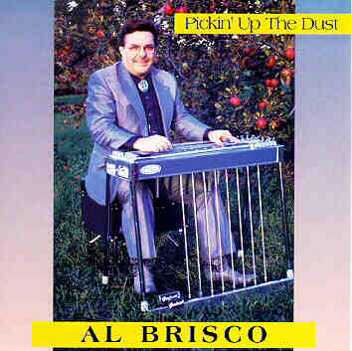

Born & raised on the family 'APPLEDALE' farm in the community of NORTHCOTE, near RENFREW, ONTARIO, CANADA, where early musical influences included the school & church. Five years of piano music lessons plus learning some chords on the acoustic guitar led to playing bass at the age of 16 with country bands.
One of these bands named The Countrymen were desirous for a steel guitar, & since there wasn't a pedal steel within many miles, Al proceeded to build his first one, from a picture on a Pete Drake LP. After many tuning frustrations, Al purchased his first factory-built pedal steel, a Fender 400 from Ken Davidson of the CFRA Happy Wanderers, finished high school & went on the road making music his career. In 1966 he took delivery of his first Sho-Bud pedal steel.
His influences over the years include Ralph Mooney, Tom Brumley, Buddy Emmons, Buddy Charleton & Lloyd Green. Since there were no cassette tapes in those days, he practiced with a LP turntable which would play at half speed, putting coins on the tone arm to slow it down to pitch. (really great for the record grooves!)
Al started doing recording sessions in the late 1960's, & in 1970 he put the hit sound on the song "COUNTRYFIED" by Dick Damron. Over the years, he has been active doing session work with such names as: George Hamilton IV, “Bustin’ Out” w/Pure Prairie League, Ian & Sylvia Tyson, Gordie Tapp, Gary Buck, Honey West, Tommy Hunter, & Johnny Burke, to name a few.
Throughout the years, Al has been in demand, playing with such artists as Grant Carson, Sons Of The Saddle, Honey West, Gary Buck, & then in 1972 he was called by Ronnie Hawkins, taking the position as band leader. During his 4 years with "The Hawks" playing mostly Rock 'n Roll, gave Al the experience of using a ‘Leslie’ organ-type speaker and a fuzz tone, taking the steel guitar into a new dimension. During this tenure he got to back up many notables, such as Frank Zappa, The Band, Kris Kristofferson, Beverly D'Angelo, & many others.
In 1976 Al joined Johnny Burke & Eastwind, one of Canada's top country groups, & in 1977 assisted in making "Wild Honey", a #1 record. Eastwind were in demand, having won RPM Magazine's Big Country Award for Canada's top country group. Consequently, Eastwind were often the first choice for back-up musicians for live gigs, as well as CTV's Funny Farm, & CFGM's Opry North syndicated radio show. During these years, Al also assisted Eddie Fulawka in building pedal steel guitars.
In 1979, Al was instrumental in starting the Steel Guitar Club Of Canada, (S.G.C.C.), now named "Steel Guitars of Canada" (SGC).
Al quit the road in 1981 & started working at Cosmo Music in Richmond Hill, Ont., where he worked for nine years, maintaining The Steel Guitar Club Of Canada, as well as playing misc. engagements. He left Cosmo in 1991, & with the assistance of his wife Betty, continues to operate his business, 'Steel Guitars of Canada' at their ‘Appledale Acres’ property near Colborne, Ontario, in addition to playing gigs, doing recording sessions, etc.
Other highlights of Al's career include the October of 1994 induction into The Ottawa Valley Country Music Hall of Fame & the subsequent release of his first solo album, "PICKIN' UP THE DUST", containing 10 pedal steel guitar instrumentals, available on CD having received fantastic reviews!

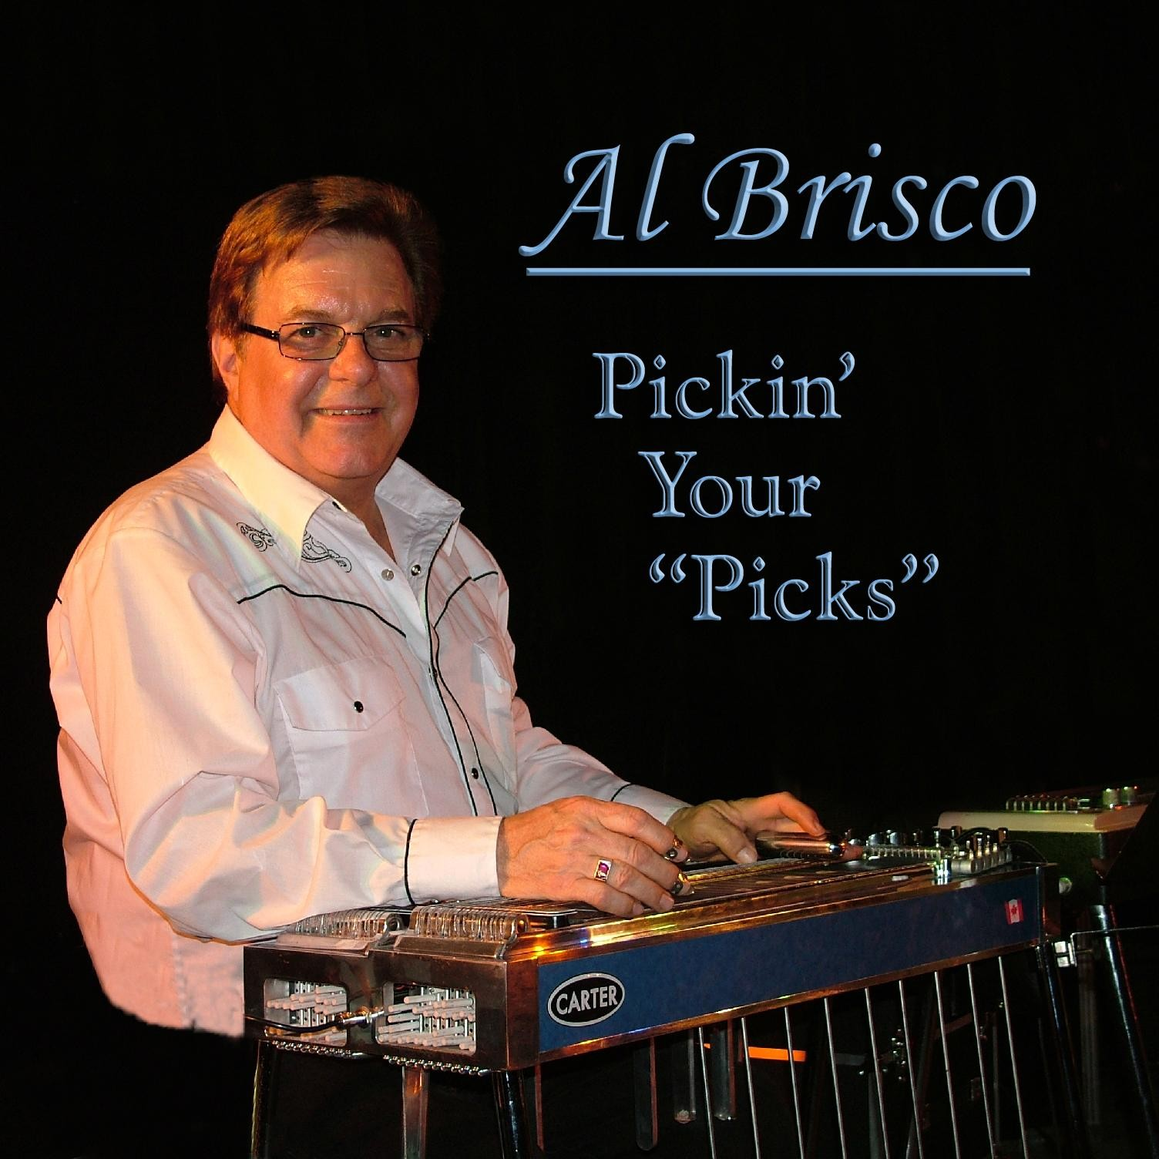

On November 28, 2004 Al was honoured with the ‘2004 Career Musician’ award at the O.C.P.F.A. (Ontario Country Performer & Fan Association) awards show & banquet.

In 2007 Al Brisco, Canada’s Ambassador of the Steel Guitar released his second solo CD of pedal steel guitar music, titled Pickin’ Your “Picks”. This is a follow-up to his very well received “Pickin’ Up The Dust” CD, which has been rated in the Top 10 Core Collection of ‘Steel Guitar’ albums of all time.

Al keeps busy, doing sessions, & playing live gigs with such artists as Carroll Baker & Baker Street, plus Freddie Vette & His Rhinestone Plowboys in Canada.

For many years now, Al has been representing Canada at some of the major ‘Steel Guitar Conventions’ around the world including “The International Steel Guitar Convention” in St. Louis, MO, & “The Texas Steel Guitar Jamboree” in Dallas, TX. Al also plays steel guitar festivals in Arizona, Connecticut, & Massachusetts. In Europe, Al has played & done steel guitar seminars in Germany, Holland, Switzerland, Ireland, & headlined Finland’s first ‘Steel Guitar Festival” in July 2008, & “The Irish Steel Guitar Festival” in October 2004 & 2008.

In June of 2014, Al was the featured artist at the Brisbane Steel Guitar Festival in Australia.

When Al is not playing gigs, he is kept busy operating his retail store, “Steel Guitars of Canada” situated on his property near Colborne, Ontario.
www.steelguitarcanada.com
Al has built this business into one of the largest ‘Steel Guitar’ stores in the world, specializing in Steel Guitars without pedals, Pedal Steel Guitars, Resonator (Dobro) Guitars, & their related accessories, amplifiers, instructional material, etc.

Al & his wife Betty enjoy the ‘Country Living’ on their property, & still enjoy their roots from The Ottawa Valley in the Renfrew & Cobden area, where many friends & family members live.
SGC/Applemus/promo/2020BriscoBio

-----****----

"KEEP STEELIN"
...But Don't Get Caught!
Best Regards,
Al Brisco

